Jackson Heart Study Protocol

Manual 3

Blood Pressure

Visit 2

Version 2.0

September 9, 2005

For Copies, Please Contact:

Jackson Heart Study Coordinating Center
Jackson Medical Mall
350 W. Woodrow Wilson Dr.
Jackson, MS 39213

FOREWORD

This manual is one of a series of protocols and manuals of operation for the Jackson Heart Study (JHS). The complexity of the JHS requires that a sizeable number of procedures be described, thus this rather extensive list of materials has been organized into the set of manuals listed below. Manual 1 provides the background, organization, and general objectives of the JHS Study. Manuals 2 and 4 describe the operation of the Cohort Procedures, Blood Pressure and Events Ascertainment Components of the study. Detailed Manuals of Operation for specific procedures, including those for Blood Pressure and Quality Assurance, make up Manuals 4 and 5. The Data Management System is described in Manual 6. The Central Laboratory and Specimen Repository is described in Manual 7. Manual 8 is designed to provide volumetric CT image data for measuring coronary and abdominal aortic calcified plaque as well as measuring body composition in the abdomen.

JHS Study Protocols and Manuals of Operation
MANUAL | TITLE
1 | General Description and Study Management
2 | Cohort Component Procedures
3 | Blood Pressure
4 | Cohort Events Ascertainment
5 | Quality Assurance
6 | Data Management
7 | Central Laboratory and Specimen Repository Collection and Processing
8 | CT Scan

Manual 3 Blood Pressure

TABLE OF CONTENTS

1.0
Sitting Blood Pressure Protocol
1.1 Introduction 1
1.2 Standardized Clinic Procedures 1
1.3 Description of the Equipment 1
1.4 Blood Pressure Measurement Instructions 3
1.5 Staff Preparation for Participant Visit 3
1.6 Measurement Procedures 3
1.7 Procedure for Changing the Peak Inflation Level 5
1.8 Reporting the Blood Pressure Results to the Participant 5
1.9 Stopping Rules for Elevated Blood Pressure 5
1.10 Sitting Blood Pressure Training and Certification 7
1.11 Quality Control 8
1.12 Technician Training and Quality Control 8
1.13 Equipment Maintenance 9
1.14 Referral of Hypertensives 9

2.0 Sitting Blood Pressure: Omron
2.1 Purpose 10
2.2 Equipment 10
2.3 Exclusions 10
2.4 Set-Up Procedure 11
2.5 Procedure 11
2.6 Tips for Ankle-Arm Measurements Error! Bookmark not defined.
2.7 Quality Assurance 15

3.0 self-monitored Blood Pressure Error! Bookmark not defined.
3.1 Introduction and Equipment 16
3.2 Preparation in Advance of Clinic Visit Error! Bookmark not defined.
3.3 Participant Instructions Error! Bookmark not defined.

3.4 Participant SMBP Follow Up

Manual 3. Blood Pressure

APPENDICES
Appendix 1 Check Procedures and Maintenance Instructions Random-Zero
Sphygmomanometer A-1
Appendix 2 Maintenance for Standard Sphygmomanometer A-2
Appendix 3 Maintenance for Omron HEM907XL Blood Pressure Monitor A-3
Appendix 4 Checklist for Biannual Observation of BP Technicians A-4
Appendix 5 Monthly Log for Sitting BP Station A-6
Appendix 6 Accuracy Check on the Random-Zero Sphygmomanometer A-9
Appendix 7 Form for Recording Simultaneous BP Observation on a Volunteer by Two Technicians A-10
Appendix 8 JHS Omron and Random Zero Comparison Checklist
Appendix 9 Omron Instruction Manual: Model HEM907XL
Appendix 10 Omron Instruction Manual: HEM-780

Appendix 11 Self Monitored Blood Pressure Teaching
Manual 3. Blood Pressure

TABLES
Table 1. Determination of Cuff Size Based on Arm Circumferenc 3

Table 2. Classification Of Blood Pressure for Adults
Error! Bookmark not defined.

Table 3. Medical Care Referral Guidelines For Blood Pressure Based On
Initial Measurements
Error! Bookmark not defined.
Table 4. Determination Of Cuff Size Based On Arm Circumference 11

Table 5. Omron HEM-780 Error Codes, Causes and Solutions
Error! Bookmark not defined.

Table 6. Omron HEM-780 Troubleshooting Tips
Error! Bookmark not defined.

FIGURES

Figure 1. Changing The Peak Inflation Level On Paper Forms5

Sitting Blood Pressure Protocol (random zero sphygmomanometer)

Introduction

As blood pressure rises, so does risk of ischemic heart disease and its complications. The range of normal blood pressures is wide. Even within the "normal" range, risk increases as the upper limits are approached. Usually, blood pressures are expressed as systolic pressure/diastolic pressure; values exceeding 140/90 mmHg are considered to be hypertensive for adults. Classification and staging of hypertension are more precise where systolic rather than diastolic is the principle criterion. Both systolic and diastolic blood pressure elevations are associated with increasing risk for cardiovascular disease. Middle-aged persons with a diastolic blood pressure of 90-104 mmHg (so-called "mild" hypertension) have a risk of heart attack that is about 70 percent higher than that of persons with a diastolic pressure under 80 mmHg (optimal value). Persons with a diastolic blood pressure exceeding 104 mmHg (moderately severe to severe hypertension) have a risk more than twice that of those with a normal value. Hypertension is an especially strong risk factor for stroke and, to a lesser extent, for peripheral vascular disease. Most of the knowledge of the consequences of high blood pressure arises from studies of sitting arm blood pressure, as described in this section.

Sitting blood pressure in the first exam (Visit 1) is measured in a resting state, using 2 measurements with a random zero sphygmomanometer. The random zero machine has two advantages over the fixed zero manometer. Digit preference does not appear in the data. It may still exist in the reading itself, but it is "removed" from the data by the use of the randomly chosen zero point. More importantly, it prevents the blood pressure technician from knowing the actual value, and therefore removes judgements about blood pressure levels for readings close to critical values such as 90 diastolic. It should be noted, however, that the random zero machines tend to yield blood pressures which are about 1.5 mmHg less than those obtained when using a fixed zero machine. Within person variation in blood pressure is substantial, even within a few minutes and particularly under conditions perceived as stressful. Use of two replicate readings tends to reduce this short-term variation.

Standardized Clinic Procedures

Correct measurement of blood pressure is of the utmost importance to the success of this study. It is essential that the procedure described below for measuring blood pressure be followed exactly. Major differences in blood pressure measurement methodology among health professionals from several countries have been observed despite the fact that a joint committee of the American Heart Association and the Cardiac Society of Great Britain and Ireland established international recommendations on blood pressure measurement in 1939. Precision is essential for valid comparisons of blood pressure between groups of people and in individuals on different occasions.

Description of the Equipment

Stethoscope

A standard Littman stethoscope with a bell is used. Korotkoff sounds, described as Phase 1 through Phase 5, are best heard with the bell because of their low pitch. Stethoscope tubing should be about 10-12 inches from the bell piece to "Y" branching. This length provides optimal acoustical properties and allows the observer to read the sphygmomanometer at eye level and in a comfortable position. Earpieces should fit comfortably and snugly in the ears. Four points should be observed in using the stethoscope.

The earpieces should be directed downwards and forwards into the external ear canal.

- The earpieces should be tight enough to exclude outside sound but not so tight that they cause discomfort.

- The valve between the bell and the diaphragm should be turned in the correct direction.

- The bell of the stethoscope should be placed lightly on the skin overlying the brachial artery - immediately below the cuff and medial to the cubital fossa above the medial epicondyle of the radius and posterior to the biceps muscle. Light pressure accentuates low-pitched sound and avoids compression murmurs. Pressing too heavily with the stethoscope over the brachial artery causes turbulent flow in the artery and a murmur can be heard which may prolong the apparent duration of phase 4.

Sphygmomanometers

Standardized Hawksley random-zero instruments are used for all clinic visits. Standard Baum manometers are used for determining peak inflation level.

The mercury manometer consists of a screw cap, a face with numbers, a lined glass column, a reservoir containing mercury, rubber tubing, and a metal case. The rubber tubing from the mercury manometer connects to the rubber tubing from the inflatable rubber bladder of the cuff. As the inflatable rubber bladder is filled with air, the air pressure in the bladder travels through the connecting rubber tubing. The pressure pushes the mercury out of the reservoir and into the lined glass column. The number for each line is read when the rounded top of the mercury, the meniscus, is level with it. If the meniscus is exactly between the lines, the reading is made from the line immediately above, i.e., rounded up to the nearest even number.

Random-Zero Mercury Manometer

The random-zero (R-Z) manometer has all the parts of the standard mercury manometer. In addition, it has a device built into the box-shaped back that changes the level of mercury in the calibrated glass tube. The device includes a second mercury reservoir the size of which can be changed to hold a larger or smaller amount of the mercury and therefore allow different amounts of mercury to remain in the calibrated glass tube and the outside reservoir. Turning a wheel on the side of the wooden box changes the size of the second reservoir. The second reservoir is opened and closed with a bellows control valve on the face of the manometer.

Cuffs and Bulbs

Proper size of the cuff is essential for accurate blood pressure measurement. The Examination Center has four standardized cuffs available - small adult, adult, large adult, and thigh cuff. The standardized cuffs (provided are by the Baum Company) are used for the measurement of sitting blood pressure.

The range markings on commercial cuffs overlap from size to size and do not offer a precise guideline. In the JHS Study arm size is measured, and the cuff size is selected as illustrated in Table 1, below.

- Determination of Cuff Size Based on Arm Circumference

 | Cuff Size | Arm Circumference
 | Small Adult | < 24 cm
 | Adult | 24 to 32 cm
 | Large Adult | 33 to 41 cm
 | Thigh | > 41 cm

Blood Pressure Measurement Instructions

Standardizing the measurement technique and the environment in which the measurement is made controls some of the many extraneous factors influencing blood pressure. Uncontrolled factors (temperature, time of day, arm circumference, recent use of caffeine, and identity of the observer) are recorded, so that they can be taken into account during analysis.

JHS participants are reminded during the scheduling of Visit 1 to avoid caffeine (from tea, coffee, chocolate, and soft drinks), eating, heavy physical activity, smoking and alcohol intake for twelve hours prior to the clinic visit. Current drug intake, including medications affecting blood pressure and non-prescription drugs, is recorded on the day of the examination. A detailed history of alcohol intake history is also recorded.

Staff Preparation for Participant Visit

In relating to the JHS participants, remember that participation in the study is voluntary. Participants are given full explanation and instructions about the preparation for the blood pressure examination and an opportunity for questions. The setting in which blood pressure measurements are made is standardized and takes place in a separate, quiet room where no other activity is taking place, and where temperature fluctuations are minimal. Clinic scheduling procedures establish consistent appointment times to minimize as much as possible the impact of daily blood pressure variation.

Measurement Procedures

The sitting arm blood pressure is measured two times at Exam 2. It takes approximately 10 minutes to make two blood pressure measurements including the initial five-minute rest.

Once the participant is given instructions and explanations, and the equipment has been checked, blood pressure measurement begins. The following steps must be followed precisely. The procedure is described here employing the JHS paper form. When using the JHS Direct Data Entry System, calculations are performed by the system.

- If the participant indicates that there is a medical or post-surgical reason for not having the blood pressure measured on the right arm (or if the right arm is missing), reverse chairs and proceed with the left arm. Indicate on the Itinerary Form and on the Sitting Blood Pressure form Note Log that the left arm is used. If in doubt, or if the participant prefers not to have a blood pressure taken on either arm, consult with the supervisor.

- Determine the arm circumference using the following procedure.

The participant stands facing away from the observer with the right arm flexed at 90 degrees at the elbow, hand across midsection. The observer determines and marks the tip of the olecranon (elbow).

The participant straightens the arm, allowing it to hang loosely at the side. The observer then determines and marks the posterior tip of the acromion process (shoulder bone). Using a centimeter tape, the observer measures the length of the upper arm between the two marks and marks the midpoint (+).

The observer wraps the tape around the arm over the midpoint mark, making sure that the tape is level. The arm circumference is measured to the nearest centimeter, and is recorded.

- Seat the participant with right arm on table. The bend at the elbow (cubital fossa) should be at heart level. Legs should be uncrossed and feet comfortably flat on the floor, not dangling. Be sure that the chair head support is comfortable and the participant is able to relax the neck and shoulder muscles as much as possible.

- Palpate the brachial artery (just medial to and above the cubital fossa), and mark this location for stethoscope placement. Choose the correct cuff size and wrap the cuff on the arm with the center of the bladder over the artery. If the participant seems particularly apprehensive, delay wrapping the cuff until after the five-minute wait.

- Record the time. Start five-minute timer. Allow a five-minute wait before taking the blood pressure. Conversation should be limited. However, a brief explanation of the procedure can be repeated at this time if necessary. The smoking and fasting questions may be asked after timing is begun.

- After the 5-minute rest, check and record the 30-second heart rate. Then, connect the cuff to a standard manometer and establish the pulse obliteration pressure by slowly inflating while palpating the radial artery until pulse is no longer felt. Deflate and disconnect the cuff. Record the pulse obliteration pressure. Record the R-Z maximum zero number (found next to mercury column). Calculate and record the peak inflation level (i.e., pulse obliteration pressure + R-Z maximum zero number + 30).

- Measurement 1: Connect the cuff to the random-zero manometer. Open the bellows control valve and wait until the mercury settles. Using downstrokes only turn the thumbwheel two or three times. Note: Do not spin the thumbwheel. Place the bell of the stethoscope on the brachial artery. Inflate rapidly to the R-Z peak inflation level. Holding the pressure constant with the bulb, wait 5 seconds. Close the bellows control valve. Slowly deflate the cuff (2 mm per second) while listening. Record the 1st and 5th phases, reading the pressure in mmHg to the nearest even number. The first sound heard in a series of at least two sounds is recorded for systolic blood pressure (phase 1). The first silence in a series of at least two silences is recorded for diastolic blood pressure (phase 5), not the last sound heard. Disconnect the cuff and record the zero reading.

- Measurement 2: Have the participant raise measurement arm for five seconds. After waiting another 25 seconds with the participant's arm on the table, repeat the measurement as in step 7 above and disconnect cuff.

Blood pressure calculations are made for the first and second readings. When using paper forms, subtract the zero value from the readings to get the actual (corrected) systolic and diastolic blood pressure measurement. This is done on the worksheet at the end of the form. Because of the importance of the blood pressure averages, to inform the participant and for the purpose of referral, all arithmetic is done with a calculator.

If for any reason the observer is unable to complete, or has forgotten to complete any portion of the exam (and the participant is gone), draw two horizontal lines through the space(s) on the form, if using paper forms. This is the correct way to indicate missed information. If an entire reading is missed and the participant is still sitting at the blood pressure workstation, completely deflate the cuff and start over with a replacement reading. However, under no other circumstances may a replacement reading be obtained. Always wait at least 30 seconds between readings.

Procedure for Changing the Peak Inflation Level

Occasionally the Korotkoff sounds may be heard as soon as one places the stethoscope over the brachial pulse. If this happens, the peak inflation level used was too low. The observer immediately deflates the cuff by releasing the thumbscrew and disconnecting the cuff tube. Then have the participant hold the cuff-wrapped arm vertically for five seconds. As shown below in Table 2, draw a line through the previously recorded Pulse Obliteration Pressure and Peak Inflation Level. Increase each number by ten and write the new number above the original one, as shown below. When using the Direct Data Entry system, the Peak Inflation Level values change automatically when the Pulse Obliteration Pressure is changed. Proceed with blood pressure measurement, starting at the new Peak Inflation Level.

- Changing the Peak Inflation Level on paper forms.

 |  | 130
 | Pulse obliteration pressure | 120
 | R-Z maximum Zero | + 22
 |  | + 30
 |  | =182
 | Peak Inflation Level | 172
 | (Random-Zero)

Reporting the Blood Pressure Results to the Participant

Using a calculator, average the first and second corrected R-Z readings and record the average on the form if using paper forms. Record this average on the transmittal slip or itinerary form in the participant's folder, and mention the results to the participant. State clearly the systolic and diastolic pressure, and indicate that the participant will receive a written report with these valves at the end of the visit.

Stopping Rules for Elevated Blood Pressure

The classification of blood pressure for adults is summarized in Table 3. The medical care referral guidelines for elevated blood pressure are summarized in Table 4. When a person has one or more sitting blood pressure measurements where the systolic reading exceeds 260 mm Hg or the diastolic reading exceeds 130 mm Hg (emergency referral), the JHS physician is consulted and the arrangements are made to transport the person to an emergency care facility. The JHS physician is also consulted and the participant is advised to seek immediate medical care (same day) when one or more systolic blood pressure measurements are between 210 and 259 mm Hg or the diastolic pressure is between 120 and 129 mm Hg (immediate referral). In both circumstances, the remaining procedures and interviews in Visit 1 are cancelled and Visit 1 is rescheduled as appropriate. When one or more systolic blood pressure levels are between 180 and 209 mm Hg or the diastolic is between 110 and 119 (urgent referral); the JHS physician is notified for urgent referral unless the physician recommends otherwise.
Table 5.1 Classification of Blood Pressure for Adults, Based on Joint National Committee on Detection, Evaluation and Treatment of High Blood Pressure (JNC-VII, 2003) Guidelines
Category* | SBP  (mm Hg) |  | DBP  (mm Hg)
Normal | <120 | and | <80
Pre Hypertension | 120-139 | or | 80-89
Stage 1 Hypertension | 140-159 | or | 90-99
Stage 2 Hypertension | ≥160 | or | ≥100
*When SBP and DBP fall into different categories, use the higher category.

Table 5.2 Medical Care Referral Guidelines for Blood Pressure, Based on Joint National Committee on Detection, Evaluation and Treatment of High Blood Pressure
(JNC-VII, 2003) Guidelines
Referral Classification | Examination Findings | Recommendation to Participant¹ | Explanation to Participant
Emergency Referral | SBP > 260  or  DBP > 130 | Transportation to emergency care facility. Stop exam and reschedule clinic visit | Your BP is very high.
Immediate Referral | SBP 210-259  or  DBP 120-129 | Consult with JHS MD. Refer to source of care immediately (today). Stop exam and reschedule clinic visit | Your BP is very high.
Urgent Referral | SBP 180-209  or  DBP 110-119 | Consult with JHS MD and proceed unless otherwise indicated. Refer to source of care within 1 week | Your BP is high.
Routine Referral | SBP 160-179  or  DBP 100-109 | Refer to source of care within 1 month | Your BP is elevated.
 | SBP 140-159  or  DBP 90-99 | Refer to source of care within 2 months | Your BP is elevated.
 | SBP 120-139  or  DBP 80-89 | Recheck in 1 year (no JHS referral) | Your BP is in the pre-hypertension range
 | SBP < 120²or  DBP < 80 | Recheck in 2 years (no JHS referral) | Your blood pressure is normal
¹ If the systolic and diastolic categories are different, follow recommendations for the shorter time follow-up (e.g., 160/85 mm Hg should be evaluated or referred to source of care within 1 month). ² Unusually low readings should be evaluated for clinical significance.

Sitting Blood Pressure Training and Certification

At the Examination Center a minimum of five clinic staff persons are trained for measuring sitting blood pressure. They need not be health professionals, but they must be trained and certified by JHS in the blood pressure measurement technique. Observers should also have experience in relating to people.

The first training session begins with a description and demonstration of the correct blood pressure measurement procedure. Trainees listen to the 1st (training) audiocassette tape, taking the test sequences until they are confident they can identify 1st and 5th phase Korotkoff sounds. Then, they use the 2nd tape until they have passed the test. After passing the second test, they are given the 3rd tape test. Alternated with the tapes are actual practice sessions with live subjects under the instruction and observation of the training supervisor. Some live practices may be done with a standard stethoscope, but most employ the Y-tube stethoscope. After the first day of training, each trainee is given a cuff and manometer (no stethoscope) to take home and practice control of the valve. This is done by wrapping the cuff on a jar or bottle and alternately pumping up and dropping the mercury at a steady rate of 2 mm per second. After two or three sessions, trainees are also given a stethoscope to practice on family or friends. Out-of-class practice is very important to build confidence. Practice time allowed in class is not enough without outside practice time. Once each trainee has passed the third tape test, he or she does at least two live readings with the training supervisor on the Y-tube stethoscope. The readings must agree within 4 mm and the average must agree within 3 mm. If they do not, the trainee needs additional practice with tapes and live subjects. The training supervisor also verifies that the trainee understands and follows proper procedures.

Additional time is allowed for instruction and mastering the use of the Random-Zero device. Trainees are certified after passing tape tests 2 and 3 (tape 4 is held in reserve for recertification) and at least 2 live readings. Observers are recertified every six months by taking and passing tape 3 or 4 and two readings with the blood pressure supervisor on an Y-tube stethoscope.

It is the responsibility of the Examination Center to conduct recertification procedures and report to the Coordinating Center when the procedures are complete.

Tapes

The JHS Study uses four tapes of Korotkoff sounds. Tape 1 is a training tape. Tape 2 is a practice tape. Tapes 3 and 4 are test tapes. A new trainee listens to tape 1, goes to tape 2 and repeats it as often as necessary. Tape 3 is taken as a test. It, too, may be repeated if necessary. Tape 4 is held in reserve for the six-month recertification. Tapes 3 and 4 are alternated thereafter for recertification.

Using the Cronus Stop Watch with the Prineas Blood Pressure Tapes

The Cronus stopwatch, model 3-S, is an interval timer and is the preferred timing device to be used with the training tapes. Of the various options, it seems to be the simplest and easiest to read. It is generally available at a local sporting goods store. The address of the manufacturer is:

Cronus Precision Products, Inc.
2895 Northwestern Parkway
Santa Clara, CA 95051 USA

If only Phase 1 and Phase 5 are learned, two ordinary stopwatches may be used. Using one in each hand, both are started at the beep; one is stopped when the first Korotkoff sounds are heard and the other stopped at Phase 5. The interval watch is preferred even if Phase 4 is not being recorded because it is much easier to change one's mind if sounds change, and it is easier to read.

- Turn on the stopwatch and press the reset button.

- Start the tape, wearing headphones. At the beginning of each tape is a timing sequence, with no Korotkoff sounds. When the beep is heard, start the watch by pressing the button at the top. Stop the watch with the button at the top when the second beep is heard. Record the time elapsed to the nearest 10th of a second on the top of the student form.

- Press reset button. When the tape announces sequence 1, start the watch at the beep.

- When the first Korotkoff sound is heard, stop the watch with the button at the top. Record the time elapsed to the nearest 10th of a second. The watch continues to run internally.

- When the Phase 5 (disappearance) is heard, stop the watch. Record the time elapsed to the nearest 10th of a second. Press reset. Repeat steps 3 through 5 for each sequence. Remember that the tapes were designed for a special timing device. The answers given are double the stop watch values. At the end be sure to turn off the stopwatch in order to save batteries. To score the tests, add all the sequences, and divide by the number of sequences. The average should be within plus or minus one second.

Y Tube Stethoscope Observations

Y Tube stethoscope observations are made in conjunction with the blood pressure tapes during initial training and for biannual quality control. The trainer has the observer-trainee go through the entire blood pressure measurement procedure using a quality control checklist. The observer and trainer listen with the Y Tube and record the values on separate sheets. Two measurements on one subject are obtained. Measurements by the trainer and the trainee should agree within 4 mmHg on any one reading (systolic or diastolic) and averages should agree within 3 mmHg.

Quality Control

To ensure the accuracy of the blood pressure measurements throughout the study, quality control measures are developed at the Coordinating Center and applied at the Examination Center. These measures include:

- recruitment of the most qualified personnel
- standardized training and certification
- retraining and recertification
- biannual observation of data collection by supervisors, using the checklist given in Appendix 3. One checklist is used for each technician and sent to the Coordinating Center each quarter.
- frequent staff meetings to provide feedback
- editing of data, both manual and by computer
- a quality assurance program administered by the Coordinating Center
- biannual simultaneous Y Tube observation of each technician by the blood pressure supervisor
- equipment maintenance program

Technician Training and Quality Control

Blood pressure technicians are trained by the clinic coordinator or their designee prior to participant recruitment. New technicians hired after the start of the study are trained locally by the Study Coordinator or a designated "Blood Pressure Supervisor". Recertification occurs every six months. Prior to certification, each technician is required to have a clinical hearing test.

The Coordinating Center directs a blood pressure quality assurance program to review six-monthly data. This includes quality analysis and review of blood pressure data, comparing means for each technician with the values for all technicians. These statistics are adjusted for weight, age and sex of the participants. Digit preference is also monitored for each technician.

Equipment Maintenance

The Examination Center is responsible for the proper operation and maintenance of its equipment. Maintenance responsibility is assumed by the blood pressure supervisor and all staff are instructed to report any real or suspected equipment problems to that person promptly.

All checks, inspections, cleanings and problems indicated are documented and recorded by date in a permanent log. Problems and solutions are also recorded. A copy of this log is given in Appendix 4.

Random Zero and Standard Sphygmomanometers

The Random Zero manometer is inspected once a week and the standard manometer once a month. These inspections include a check of:

- the zero level of the standard manometer
- mercury leakage
- manometer column for dirt or mercury oxide deposit
- condition of all tubing and fittings.

The equipment is cleaned if inspection indicates it is needed, or at least once a year. Specific instructions for the random zero device are provided in Appendix 1, and for the standard manometer in Appendix 2. In addition, every two months the accuracy of the random zero instrument is checked using a standard manometer and an Y connection, as described in Appendix 4.

Referral of Hypertensives

As shown in Table 3, blood pressure referral levels are made based on the findings of the JHS examination which are consistent with the recommendations given in the seventh report of the Joint National Committee on Detection, Evaluation, and Treatment of High Blood Pressure (2003). The average of the first and second resting blood pressure readings is used.

Sitting Blood Pressure (omron HEM-907XL) Blood Pressure Protocol and BLOOD PRESSURE comparability study Purpose

This protocol is written for use with the Omron HEM907XL automated BP monitor. Special attention must be placed on assessment and maintenance of the instrument’s accuracy as per the manual that accompanies the instrument (Appendix).

The design and operation of the Omron HEM907XL are based upon the combined principles of compression of the brachial artery under an elastic, inflatable cuff and estimation of the systolic and diastolic BP levels by oscillometric methods. All readings are to be recorded to the nearest digit.

The Omron HEM907XL unit will undergo and Blood Pressure Comparability study to assure comparability between measures of blood pressure taken with this equipment and that taken using the Random Zero sphygmomanometer. The purpose of this comparability study is to assure that blood pressure taken by either type of equipment can be considered equivalent for data analysis purposes for the JHS. Once the comparability study is complete, and reliability of measurements determined, the Omron HEM907XL equipment will be used for all off-site examinations conducted as a part of Exam 2.

Equipment

The following equipment will be required for BP and pulse measurement:
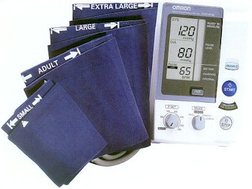
1. One Omron HEM907XL automated BP monitor.
2. BP cuffs in four sizes: S, M, L, XL
3. One Gulick II tape (or Gulick II Plus)
4. A chair with arm support for BP measurement, or a chair and table (table must provide for a comfortable resting posture of the arm with the cubital fossa at the level of the 4th intercostal space at heart level)
5. One black pen (marking on skin) and one No. 2 pencil (completing the form)

Exclusions

- Persons with rigid arteries such that an occlusion pressure cannot be reached. If the artery cannot be occluded before the mercury column reaches 300 mmHg, the participant is excluded.
- Persons with bilateral amputations of arms.
- Subjects who fit any of the above categories are recorded as missing data.
- If a subject has undergone a mastectomy of the right breast or has other reasons to omit right arm pressures, the left arm will be used for measures.

Set-Up Procedure
The proper cuff size must be used to avoid under- or over-estimation of BP. Cuff size refers to the cuff’s bladder, not the cloth. A copy of the chart below should be attached to the sphygmomanometer for easy reference. In addition, the cuffs must be HEM907 XL-compatible (see manual in Appendix). If the right arm cannot be used, the left may be used. This change must be noted on form.

- Determination of Cuff Size Based on Arm Circumference

 | Cuff Size | Arm Circumference |  | Bladder Size
 | Small Adult | < 24 cm |  | 9.0
 | Adult | 24 to 32 cm |  | 12.0
 | Large Adult | 33 to 41 cm |  | 15.0
 | Thigh | > 41 cm |  | 17.5

Measurement of arm circumference. The participant should remove his/her upper garment, or clear the upper arm area so that an unencumbered measurement may be made. The technician should:

- Have the participant stand, with the right arm hanging and bending the elbow so that the forearm is horizontal (parallel) to the floor.

- Measure arm length from the acromion (bony protuberance at the shoulder) to the olecranon (tip of the elbow), using the Gulick II anthropometric tape.

- Mark the midpoint on the dorsal surface of the arm.

- Have the participant relax arm along side of the body.

- Draw the tape snugly around the arm at the midpoint mark.
NOTE: Tape should be horizontal and should not indent the skin.

- Noting the arm circumference indicated by the tape, use the criteria above for determining cuff size.

Procedure

2.5.1 Wrapping the Blood Pressure Cuff around the Arm
The technician should:
1. Ensure the participant is seated, legs uncrossed, in a quiet room, with the elbow and forearm resting comfortably on the armrest of the BP measurement chair (or table), with the palm of the hand turned upward. The area to which the cuff is to be applied must be bare (free of clothing).
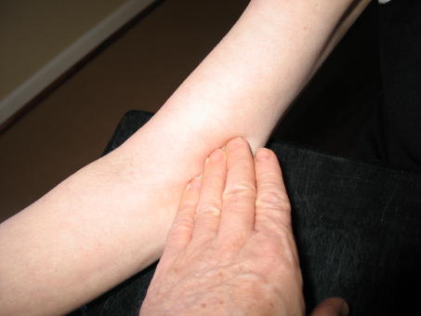
2. Locate the brachial artery by palpation and mark the skin with a small dot, using a black pen. (The brachial artery is usually found just medial and superior to the cubital fossa, posterior to the biceps muscle and slightly toward the body). For brachial artery palpation, fingertips or thumb may be used (see figures to the right).
3. Place the appropriate cuff around the upper right arm so that:
- The midpoint of the length of the bladder lies over the brachial artery.
- The cubital fossa is at heart level.

NOTE: The midpoint of the length of the bladder should be confirmed by folding the bladder in two. The marking on the cuff should not be trusted.
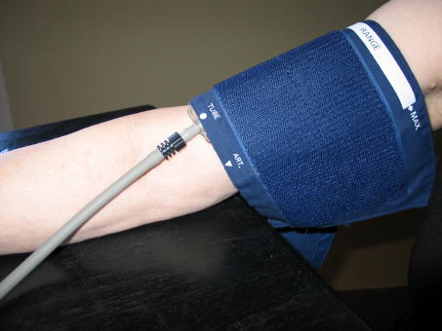

4. Place the lower edge of the cuff, with its tubing connections, about 1 inch above the natural crease across the inner aspect of the elbow (the cubital fossa).

5. Wrap the cuff snugly about the arm, with the palm of the participant’s hand turned upward, making sure the long edges of the cuff lie on top of each other as the cuff is wrapped around.

6. Secure the wrapped cuff firmly by applying pressure to the locking fabric fastener over the area where it is applied to the cuff.
NOTE: The cuff should not be wrapped too tightly around the arm.

General Guide to Blood Pressure Readings

- Following any previous inflation, wait at least 30 seconds after cuff has completely deflated.
- By closing the thumb valve and squeezing the bulb, inflate the cuff at a rapid but smooth continuous rate to the maximal inflation level (30 mmHg above systolic pressure). This measure is described in greater detail below.
- The examiner’s eyes should be level with the mid-range of the manometer scale and focused at the level to which the pressure will be raised.
- By opening the thumb valve slightly, and maintaining a constant rate of deflation at approximately 2 mmHg per second, allow the cuff to deflate.
- Listen throughout the entire range of deflation, past the systolic reading (the pressure where the first regular sound is heard) for 10 mmHg. Two subsequent beats should be heard for any valid systolic blood pressure reading.
- Deflate the cuff fully by opening the thumb valve.
- Neatly enter systolic readings in the spaces provided on the form.

Blood Pressure Comparability Study Methods
The BP Comparability Study is done with a subset of JHS participants who are willing to participate in this extra measurement. Participants with an arm circumference exceeding 50 cm and requiring the use of a thigh cuff are ineligible to participate in the BP Comparability Study.

Equipment

- Standard sphygmomanometer

- Standard cuffs

- Single stethoscope with bell

- Double Y-stethoscope with bell

- Omron HEM907XL

- Random Zero

- Y-connector

- Omron cuffs

2.5.2 Staff

Two BP technicians: Each will record three measurements on the BCF form for use by the Random Zero (RZ) technician and the Omron technician. Two BP measurements will be made on each BP Comparability Study participant. The technicians will alternate observations using the RZ and Omron. Technician No. 1 will measure a participant’s BP twice with the RZ, and Technician No. 2 will measure the participant’s BP twice with the Omron. The next participant would have Technician No. 2 measure BP twice with the RZ, and Technician No. 1 measure BP twice with the Omron. During the comparability study, Omron measurements are made with the setting on MANUAL. The Omron technician listens with the same double stethoscope as the RZ technician.

2.5.3 Random Zero Technician Procedures

The RZ technician should:
1. Enter his/her Technician ID in the space provided at the bottom of the BCF form.
2. Measure and record participant’s arm circumference with Gulick II tape.
3. Select and apply an appropriate sized standard cuff according to the participant’s arm circumference measurement.
4. Determine and record the Pulse Obliteration Pressure using the standard sphygmomanometer and a standard cuff with the technician’s hand on the participant’s radial pulse.
5. Add and record 30 mm to the Pulse Obliteration Pressure.
6. Switch from the standard sphygmomanometer to the RZ. (Omron technician will remove standard cuff and apply Omron cuff.)
7. Record the RZ maximum value for the RZ in use. Enter Item 15 (sum of Pulse obliteration, maximum zero + 30 values) to determine the peak inflation value for the Omron P-Set level (Q4) setting.
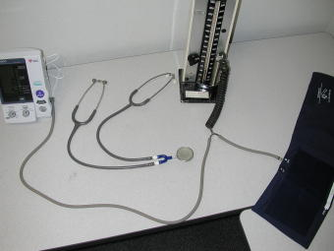
8. Attach Y-connector to the RZ, the Omron, and the Omron cuff. The small connector on this cuff should be removed so that the tubing can be attached to a Y-connector.
9. Turn the bellows valve dial on the RZ to OPEN, after the Omron technician has set up and turned on the Omron,.
10. Place the double Y-stethoscope earpieces into ears (at same time as other technician).
11. Observe the other technician press the START button on the Omron, ensuring it inflates the cuff for both devices, and that the mercury column in the RZ rises.
12. Turn the RZ dial to CLOSE, when the mercury column on the RZ has dropped 20 mm from its highest point.
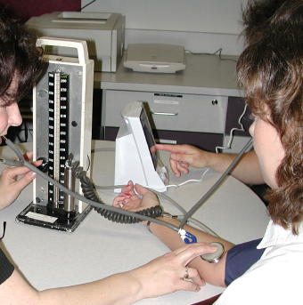
13. Listen for the onset of the 1st sounds and 5th (disappearance) Korotkoff phase sounds.
14. Record readings from the RZ, when the cuff is completely deflated, and subtract the RZ level from the RZ systolic and diastolic readings, recording the corrected measurement.
15. Open the RZ dial and turn the thumb wheel.
2.5.4 Omron Technician
The Omron technician should:
1. Enter his/her Technician ID in the space provided at the bottom of the BCF form. Remove the standard cuff, after the RZ technician has completed the peak inflation level measurement, and apply the appropriate sized Omron cuff to the participant’s arm with the arrow at the brachial artery.
2. Turn on the Omron (It is best to have the Omron connected to the main power supply, rather than relying on the battery power). Turn the P-SET dial on the Omron to the P-Set level estimated in [2.6.3(7)], above. PLEASE NOTE: If using Omron equipment without prior Random Zero methods, enter the P-Set level as the pulse obliteration level + 30.
3. Turn the MODE on the Omron to MANUAL.
4. Place the double Y-stethoscope earpieces into his/her ears (at same time as other technician) and hold the bell over the participant’s artery.
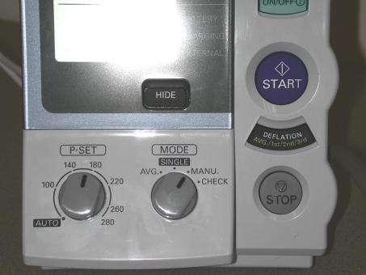
5. Press START on the Omron. The Omron will inflate the cuff for both devices.
6. Watch the Omron and listen for the onset of 1st (sounds) and 5th (disappearance) Korotkoff phase sounds, noting the pressure levels.
7. Record the systolic and diastolic BP levels from the Omron, when the cuff is completely deflated and the Omron is at “0.”

2.5.5 Second Blood Pressure Measurements

The above steps should be repeated, starting at Step 2.6.3.(7) for the RZ technician and Step 2.6.4.(5) for the Omron technician. Each technician should take both measurements with the same device. The RZ technician will continue to record the measurements in the Random Zero section of the BCF form and the Omron technician will continue to record measurements in the OMRON section of the form.

2.5.6 Measurements Using Omron Only Equipment

When taking measurements using ONLY the Omron equipment, follow all the instructions above for the Omron Technician except:

- only one technician is required
- Set the P-SET value to AUTOMATIC and record the maximum inflation on the monitor before the monitor begins automatic deflation as the P-set value.
- Set the MODE to AVG. The monitor will automatically take two measurements one minute apart displaying the first, second, and average blood pressure readings. Record each as directed in the SBP QxQs for the relevant items.

Quality Assurance

Training Requirements

Staff performing the ankle-arm index measurements should be research technicians or clinicians previously trained in taking research blood pressure measurements. In addition, training should include:

- Read and study manual
- Attend Jackson Heart Study training session on techniques (or observe administration by experienced examiner)
- Practice on volunteers
- Compare measurements with those made by experienced colleagues (Goal: obtain measurements within ± 2 mm Hg of that observed by a trainer)
- Discuss problems and questions with QC officer

Certification Requirements

- Complete training requirements
- Recite exclusion criteria
- Conduct exam on two volunteers while being observed by QC officer listening with Y stethoscope

Self monitored blood pressure

Introduction and Equipment

The self monitored blood pressure component of Exam 2 includes instructing the participant in the use of the Omron HEM-780 Intellissence Automatic Blood Pressure Monitor and providing opportunity for the participant to satisfactorily measure her/his blood pressure prior to leaving the clinic. This monitor is ideal for self monitoring as it uses oscillometric methods of blood pressure measurement to detect blood movement through the brachial artery and converts these movements to a digital reading. Thus, no stethoscope is needed simplifying the use of this equipment.

The HEM-780 comes with the following components:

Monitor ComFit Cuff
AC Adapter 4 “AA” Batteries
Storage Case Instruction Manual

Preparation in Advance of Clinic

Clinic staff will prepare each monitor in advance of the clinic session by setting the date and time following the instructions in the HEM-780 Instruction Manual (Appendix). This will shorten the time needed for the participant’s to learn to use the equipment for blood pressure measurement.

- Press the Date / Time Setting button. The Year flashes on the display.
- Setting the Year. The year can be set between 2004 and 2030. If you accidentally advance to 2030, it will return to 2004. Press the ► memory up button to advance by increments of one year. Press the Date / Time Setting button. The Month flashes on the display
- Setting the Month. Press the ► memory up button to advance by increments of one month. Press the Date / Time Setting button. The Day flashes on the display.
- Setting the Day. Press the ► memory up button to advance by increments of one day. Press the Date / Time Setting button. The Hour flashes on the display.
- Setting the Hour. The Time is set using AM or PM. Press the ► memory up button to advance by increments of one hour. Press the Date / Time Setting button. The Minute flashes on the display.
- Setting the Minutes. Press the ► memory up button to advance by increments of one minute. Press the Date / Time Setting button to set the current minute. The Year flashes on the display.
- Press the START / STOP button to turn the display off.

Participant Instructions

Participants will be instructed in the proper application and removal, blood pressure measurement, use of the memory function, care and maintenance, and trouble shooting for common error codes of the Omron 780-HEM SMBP device during the clinic visit. Safety features will be reviewed. Review the SMBP Instructions to Participants and the HEM-780 Instruction Manual with participants.

Provide participants with a copy of the SBPM Participant Instructions and the JHS Blood Pressure Diary. Inform participants that they will be called in 2-6 weeks to assure that they are having no difficulties with SMBP measurement and to obtain their most recent readings from their monitor’s memory.

Preparing to Take a Measurement

Instruct participants to follow these recommendations in order to ensure a reliable blood pressure reading:

- Avoid eating, smoking, and exercising for 30 minutes before taking a measurement. Rest for at least 5-15 minutes before taking the measurement
- Avoid taking measurements during stressful times as stress may elevate the blood pressure
- Take measurements in a quiet place
- Remove tight fitting clothing from the right upper arm (Please note with the participant that this is DIFFERENT from what is written in the Instructions Manual accompanying the monitor)
- Sit in a chair with your feet flat on the floor resting your right arm on a table so that the cuff is at the level of your heart
- Remain still and do not talk during the measurement
- Try to measure your blood pressure at the same time of day each time you measure it
- Take three measurements one or more minutes apart at one sitting
- Make sure to wait at least 1 minute between readings to allow arteries to return to pre-blood pressure measurement condition
- Keep a record of readings from blood pressure and pulse for your health care provider.
- Use the HEM-780 memory function to obtain an “average” of the last three blood pressures taken at one sitting
- Record the average on the Blood Pressure Diary

Place the blood pressure main using on the table. Insert the AC Adapter into the back of the unit and plug it in to a 120V AC wall outlet. When disconnecting the AC Adapter, unplug it from the back of the monitor prior to unplugging it from the wall outlet.

Applying the Arm Cuff

The HEM-780 SMBP device is supplied with a ComFit cuff that accommodates all but the very largest arm sizes. Plug the air plug securely into the main monitor on the left side of the unit. The arm cuff will be applied to the participant’s RIGHT arm, unless there are compelling reasons to do otherwise (for example, amputation, mastectomy, dialysis shunt, etc). Turn the palm of the right arm upward. Holding the grip on the cuff securely with the left hand, apply the cuff to the right upper arm so that the blue strip is on the inside of the arm and aligned with the middle finger. The bottom of the cuff should be approximately ½ inch above the elbow. Wrap the cuff firmly in place using the Velcro strip. Be careful not to rest the arm on the air tube as this will restrict the flow of air to the cuff, preventing it from inflating.

Taking a Measurement

- Initiate a reading by pressing the START/STOP button. All display symbols will appear on the face of the monitor and the cuff will start to inflate automatically

SPECIAL CONDITIONS: If the participants’ systolic blood pressure in known to be more than 220 mm Hg, press and hold the START/STOP button until the monitor inflates to 30 or 40 mm Hg higher than the suspected systolic blood pressure, taking care not to apply more pressure than necessary.

- Inflation stops automatically and the measurement is started. As the cuff deflates, decreasing numbers appear on the display and the Heart Symbol ( ♥ ) flashes at every heart beat
- The arm cuff completely deflates when the measurement is complete
- The blood pressure and pulse are displayed
- Press the START/STOP button. Rest for 1-3 minutes with feet flat on the floor and without talking or moving
- Initiate a second and third reading by pressing the START/STOP button and following steps 1-4 above.
- Press the ◄ memory down button. The average value symbol will display on the screen with the average blood pressure reading.
- Record this reading in your Blood Pressure Diary

Using the Memory Function

The date and time is alternately displayed with the measurement values selected. Press the ◄ memory down button to display the most recent measurement value on the screen. Press the ►memory up button to display the oldest measurement values. Continue to press the down (or up) button repeatedly to display the next most recent (or next oldest) values.

To delete all values in the memory, hold the ◄ memory down button AND the STOP / START button at the same time for more than 2 seconds.

Error Codes

The monitor is designed to illustrate a pictorial code if there is a problem in taking a measurement.
The following list contains a brief description of the event codes which appear on the monitor display.

Table 5. Omron 780-HEM Error Codes, Causes, and Solutions
Symbol | Cause | Correction
E | Monitor did not detect pulse rate | Remove the arm cuff. Refer to 13 in the Instruction Manual—“Applying the Arm Cuff.” Wait 2-3 minutes. Take another measurement.
EE | Cuff under-inflated | Remove the arm cuff. Read p 16 in the Instruction Manual – “Taking a Measurement.” Wait 2-3 minutes. Take another measurement.
E  E | Cuff over-inflated | Remove the arm cuff. Read p 16 in the Instruction Manual – “Taking a Measurement.” Wait 2-3 minutes. Take another measurement.
■ | Batteries are worn | Replace the 4 batteries. Refer to p 8 in the Instruction Manual for battery installation directions.

Other troubleshooting tips include:

Table 6. Omron 780-HEM Troubleshooting Tips
Problem | Causes and Solutions
No power  No display appears on unit | Replace worn batteries  Check the battery installation for proper placement of the battery polarities
Measurements appear too high or too low | Blood pressure varies constantly.  Many factors including time of day, how you wrap the cuff, stress may affect your blood pressure.  Review the sections “Before Taking a Measurement” and “Taking a Measurement” in your Instructions Manual

3.2.6 Care and Maintenance of the Monitor

Instruct the participant to follow the directions listed below to keep her/his blood pressure monitor in the best condition and to protect it from damage

1) Keep the monitor in its storage case when it is not in use. Make sure that the AC Adapter is placed under the main unit so that it does not damage the display screen

2) Do not forcefully bend the arm cuff or the air tube. Do not fold tightly

3) Clean the monitor with a soft dry cloth using no abrasive or volatile liquids. Do not attempt to clean the cuff. Never immerse the unit or any of its components in water

4) Store the unit in a clean, dry place and do not subject it to extremes of heat or cold, humidity, or direct sunlight

5) Try not to subject the unit to strong shocks, such as dropping it on the floor

6) Remove the batteries if the unit is not used for 3 or more months

7) Use the unit in accordance with the Instruction Manual and only use authorized parts and accessories

3.2.7 Safety Information

The Omron HEM-780 blood pressure monitor should be used only in accordance with the Instruction Manual accompanying the unit for the purpose of measuring blood pressure and pulse. The participant should complete the Product Registration form within 10 days of receiving the unit and mail it to:

Omron
PO Box 174378
Denver, CO 80217-4378

This will register the unit and enable the product warranty. Any attempt to disassemble or repair the unit or its components will void the user warranty.

Instruct the participant to follow her/his health care provider’s recommendations regarding blood pressure. The unit is only intended for use in adults and should not be used with children or infants or persons who cannot express their intentions.

Instruct the participant not to:

- Use a cellular phone near the unit as it may result in operational failure
- Plug or unplug the AC Adapter unit with wet hands

Participant SMBP Follow Up

The SMBP nurse will complete a telephone follow up with each participant to assure that s/he is not having any difficulties with using the equipment. During that call, the participant will be asked to provide information on the most recent readings taken with their monitor. Information regarding participant use of equipment, satisfaction, and blood pressure readings will be recorded on the Post Self Monitored Blood Pressure (ASB) form in accordance with the QxQs (Forms Appendix).
APPENDICES

Appendix 1 Check Procedures and Maintenance Instructions Random Zero Sphygmomanometer

- Check cap of manometer column to be sure it fits properly and is tight. The 0 ring or seal must be seated correctly. Clean cap of any mercury (Hg) beads or dust. The cap should be firmly finger tight. Any time the mercury seems to 'bounce' in the column of either a standard manometer or random zero (R-Z) manometer, it may be due to a loose cap. Check the opening. If it becomes blocked, the mercury column falls too slowly due to a vacuum effect. This may result in false high readings and an erratically oscillating column. This procedure should be carried out for both standard manometers and R-Z's.

- Remove back of case (two screws at top of face and two at bottom rear of case). Swing back from the left around the thumbscrew on the right side. Check for spring placement - it should be in line. Tighten all screws except the one holding the bellows plate in place.

- Wrap an arm cuff around a bottle or can.

- With reservoir valve open (newer models do not have a reservoir valve) and bellows valve closed, pump mercury to top of column (270-290 mmHg). If the mercury holds at a steady level for 15 seconds or drops 2-4 mm, that system is airtight.

- With the high pressure still in the system, close the reservoir and disconnect cuff to see if that valve holds steady pressure. If a leak is discovered in the reservoir valve, remove hose and valve (with Allen wrench). Valve handle unscrews or lifts off. There are two 0 rings on the valve stem. Clean stem and replace 0 rings. Use stopcock grease in 0 rings and valve.

- If the closed reservoir valve is tight, but there was a leak with it open, check the inflation assembly. There may be a leak in the bulb, valve, or cuff. To test the inflation assembly, immerse each section, especially valves and tubing connections in water while the pressure is high and watch for air bubbles. To test the tubing of the Hg reservoir, put soapy water on it. Most leaks occur at or near tubing connections or from valves. If a valve leaks sometimes a shot of silicone lubricant on the thumbscrew and worked in will solve the problem. Otherwise it may need to be replaced. Tubing leaks near a connector can be repaired by removing the connector, cutting off 1/2 to 3/4 inches and replacing the connector. Lubricate a sharp knife with soapy water to make the cut, and lubricate the cut tube to make it easier to reattach.

- Turn R-Z with back toward you. With bellows valve open, retract mercury to just below the plexiglass valve chamber. Close the bellows valve, pump mercury to top and visually check that leakage does not occur at that valve point. If Hg rises into the chamber, the valve needs repair. Replacing 0 rings on that valve can be done locally if someone is qualified to do it. It is a more difficult job than on the reservoir valve. Otherwise it should be sent to Baum. A serious leak in this valve can affect blood pressure readings. Whenever the manometer tube seems dirty in the area of the 'zeros' or if the Hg seems to hang up there, the tube should be cleaned. A dirty tube can affect 'zero' readings. To clean tube, set cam at lowest zero. Pump up, close bellows valve, and release pressure. This leaves little mercury in the column. Tilt manometer, getting rest of mercury out of glass and into reservoir. Close reservoir valve. Lean manometer at angle so that no mercury is in glass. Remove the tube and clean tube and seats. Check to be sure that the rubber gaskets are seated properly. Replace tube. Only a qualified person in a controlled setting should do this procedure. The manometer is set in a catch basin so that no mercury can escape. There should be a rap-type vacuum pump available to pick up any small spills.

- Check "maximum" and "minimum" zeros and of bellows and cam function. (This must be done only if there are doubts about the values of those zeros or functions; or if Hg has been added or lost.)

a. Release all pressure and open the bellows valve. The large thumb wheel with the black rubber "tire" and the cam against which it is pressed should turn freely without binding. If they do bind, bring in the R-Z.

b. Inflate the system while watching the large (about 2-1/4" diameter) disc above and to the left of the bellows valve chamber. (Bellows valve is still open.) As pressure rises one can see the disc, a piston, pushed toward the back plate until a ring around the center of the disc touches the forward rim of the cam. That rim is tapered, and thus determines how far the piston can move, depending on the position of the taper in relation to the ring at the center of the piston - a matter of change in normal operation of the R-Z. The distance that the piston can move before being stopped by the cam determines the volume of Hg in the bellows chamber; hence the volume of Hg left in the rest of the manometer.

c. To read "maximum" zero, release pressure with bellows valve still open. Turn the cam so that the point of its taper nearest the piston will be hit by the ring of the piston. (It may take an inflation and deflation or two before you find the correct cam position, which allows the minimum volume of Hg in the bellows chamber, hence maximum Hg in the rest of the system.) Inflate to about 200 mmHg, close the bellows valve, release pressure and read the zero as usual; this is the "maximum". Repeat the procedure once or twice, checking the cam position to make sure you get the same reading. Note that this is not a fixed value for if you were to inflate to 300 before closing the bellows valve, the reading would be lower; and inflation to 120-130 would give a higher value. For this reason, always record the maximum zero reading when taking blood pressures.

d. "Minimum" zero is measured as in c above, except that the cam is turned so that the piston can travel its maximum. It is usually nearly 20 mm lower than the "maximum" and should not be closer than about 4 mm to the 0 on the manometer tube scale.

e. Replace the rear case, putting it over the thumb wheel first. Start all four screws before tightening any. Take care not to cross thread.

f. After a series of blood pressure readings or before transport, open the bellows valve to drain Hg from that chamber, then close it and the reservoir valve. Between readings, the bellows valve should be left on "open" so that pressure on the bellows is not left in the device.

Appendix 2 Maintenance Procedures for Standard Sphygmomanometer

The following checks should be conducted at least every month, and a log kept of the dates and the people carrying out the troubleshooting (see Appendix 4).

- With the instrument placed flat on the table, and the inflation system disconnected, the level of mercury should read zero in the standard instrument. If the reading is either above or below the zero mark, mercury should be added or withdrawn until it does read zero. The top of the meniscus is on the zero line when the eyes are level with this line and the mercury is correctly adjusted.

- The inflation system should then be reconnected, and the cuff rolled around a bottle and secured. The valve should be closed on the Air Flo system, and the instrument inflated until the mercury rises to 240 mmHg. The Air Flo valve should then be slowly opened and the mercury allowed to fall to 200 mmHg. The valve should then be closed; at which time the mercury column should remain stable. If the column continues to fall, there is an air leak, and the following step should be taken:

- The system should be reinflated until the column rises to 200 mmHg. The tubing should be pinched at various locations to localize the area of the leak. Appropriate replacement of the tubing, cuff, or valve should be performed.

- With the instrument inflated above full calibration, the screw cap should be examined for mercury leaks. If this happens, the screw cap should be tightened. If the leak persists or the mercury is seen at the bottom of the tube, the silicone rubber, which provides a seat for both ends of the glass tube, should be replaced.

- With time, the mercury will become dirty and an oxide layer will be deposited on the inside of the glass tube. The instrument should be laid nearly on its side (on a tray) so that the mercury will return to the reservoir and none can be seen in the glass tube. The tube should be removed carefully and cleaned out using the long pipe cleaner supplied with the instrument. The tube should then be replaced and the zero level rechecked.

Since mercury is a toxic substance all maintenance procedures must be performed carefully and with attention to safety. Mercury should not be allowed to get in contact with rings and other jewelry.

(Maintenance instructions for the standard sphygmomanometer are adapted from those given for the MRFIT study in Controlled Clinical Trials, Vol. 7, No. 3 (Supplement), Sept. 1986.

Appendix 3 Check Procedures for Maintenance of the Omron HEM907XL Blood Pressure
Equipment

The following checks should be conducted at least every month, and a log kept of the dates and the people carrying out the troubleshooting (see Appendix 4).

1. Assemble the following equipment:
2. Connect the manometer, inflation bulb, cuff, and the monitor with the T-tube (see p 26 of the Omron HEM907XL Instruction Manual.
3. Tightly wrap the cuff over a sturdy cylinder
4. Release the valve of inflation bulb to remove the air inside the cuff completely
5. Set the MODE to “CHECK”
6. Close the valve of inflation bulb and inflate the cuff to the pressure to be checked, based on the manometer read
7. Compare the pressure values displayed on the monitor with the one on the manometer

CHECK RESULT: The accuracy of the monitor should be validated to ±3 mmHg or 2% of standard manometer reading. If the result shows a difference exceeding this tolerance, contact Omron repair department (1-877-216-1336).

Appendix 4 Checklist for Biannual Observation of BP Technicians by BP Supervisor

BP Technician Code #_______ Observer Code #_______

Date Observed ____/____/_____

_______________________________________________________________________

Instructions: For each item, check "yes" or "no" in the space provided to indicate if the procedure is carried out correctly. Record any comments in the blank line between that item and the next. For certain items specific parts of the procedure which are important are listed separately. Supervisor should recheck all measurements and procedures.

 | Yes | No
ALL:
Measures arm for correct cuff size | ( ) | ( )
Palpates brachial artery | ( ) | ( )
Marks pulse point | ( ) | ( )
Wraps cuff center of bladder over brachial pulse | ( ) | ( )
Leaves subject for five minutes rest | ( ) | ( )
Instructs on Posture | ( ) | ( )
Full five minutes for rest allowed | ( ) | ( )
Work station free of excessive noise | ( ) | ( )
Explanation | ( ) | ( )
Count radial pulse 30 seconds, record reading | ( ) | ( )
RANDOM ZERO AND COMPARABILITY STUDY
Finds Pulse obliteration point using standard manometer | ( ) | ( )
Calculates peak inflation, standard manometer | ( ) | ( )
Calculates peak inflation, R-Z | ( ) | ( )
If computer is down use the formula (pulse obliteration pressure + R-Z maximum zero number + 30
Explanation | ( ) | ( )
Connects R-Z tube to cuff | ( ) | ( )
Sure reservoir lever open (newer devices have no lever) | ( ) | ( )
Opens bellows valve and waits full 3 seconds for mercury to settle | ( ) | ( )
Turns thumb wheel (down strokes only) | ( ) | ( )

 | Yes | No
Places stethoscope in ears | ( ) | ( )
Inflates rapidly to R-Z peak | ( ) | ( )
Counts full 5 seconds with pressure steady | ( ) | ( )
Closes bellows knob | ( ) | ( )
Places bell on brachial pulse | ( ) | ( )
Deflates cuff 2 mmHg per second | ( ) | ( )
Deflates cuff after 2 absent sounds | ( ) | ( )
Records readings | ( ) | ( )
Disconnects tubes | ( ) | ( )
Reads zero value | ( ) | ( )
Subtracts zero value from each BP reading, if using paper form | ( ) | ( )
Instructs to hold arm vertical for full 5 seconds | ( ) | ( )
Waits at least 30 seconds before proceeding | ( ) | ( )
Repeats R-Z readings | ( ) | ( )
Informs participant of average readings | ( ) | ( )
OMRON
Assure unit is properly plugged into wall unit | ( ) | ( )
Push ON/OFF button to turn on power | ( ) | ( )
Set the MODE for AVG (if off site)  Set the MODE for MANU if on site | ( ) | ( )
Set the P-SET to AUTO (if off site)  Set the P-SET to = Item 15 SBP-B (if on site) | ( ) | ( )
Wrap the proper size cuff on arm | ( ) | ( )
Press the START button to take measurement | ( ) | ( )
Records the first measurement | ( ) | ( )
Records the second measurement | ( ) | ( )
Records the average measurement (if off site) | ( ) | ( )
Push the ON/OFF button to turn the power off | ( ) | ( )
Inform the participant of the average reading | ( ) | ( )

Special Comments:

______________________________________________________________________________

______________________________________________________________________________

______________________________________________________________________________

Appendix 5 JHS Monthly Log for Sitting Blood Pressure Station

Month________Year________

Weekly Check Procedures:
 |  |  |  | Week
 |  | 1 | 2 | 3 | 4 | 5
1. | Random-Zero Sphygmomanometer:
 | Date of Check | _____ | _____ | _____ | _____ | _____
A. | Check Tube for Oxide Dust | _____ | _____ | _____ | _____ | _____
B. | Check Cap for Tightness | _____ | _____ | _____ | _____ | _____
C. | Check Omron for Accuracy | ______ | _____ | ______ | ______ | _____

Procedures performed only if there appear to be problems:

C. If mercury bounces even though the cap appears tight, remove cap, clean of any mercury beads, and check opening at top of tube for dust

 | Check Needed and Performed during weeks | 1 | 2 | 3 | 4 | 5
 | (Circle number of weeks applicable)

D. If tube appears "dirty" (oxidized mercury) remove cap, tip manometer to retract mercury, run pipe cleaner down, replace cap

 | Needed and Performed during weeks | 1 | 2 | 3 | 4 | 5
 | (Circle number of weeks applicable)

E. List the problem encountered, the date, and the actions taken below:

_________________________________________________________________________

_________________________________________________________________________

_________________________________________________________________________

Monthly Check Procedures:

A. Accuracy Check on Random-Zero Sphygmomanometer (to be performed every 2 months):

Date last accuracy check performed: _____________

Is an accuracy check due this month? ( ) Yes ( ) No

Date accuracy check performed, if due: _____________

Problems found on accuracy check? ( ) Yes ( ) No

If yes, list problems found and corrective action taken:

_________________________________________________________________________

_________________________________________________________________________

_________________________________________________________________________

Random Zero Sphygmomanometer Check

Standard | 200 | 170 | 140 | 100 | 60
Random Zero | ____ | ____ | ____ | ____ | ____
Zero | ____
Corrected
R-Z Measure* | ____ | ____ | ____ | ____ | ____

Corrected R-Z measure = [(Random-Zero) - Zero]

Note that this corrected R-Z measure must be within 2 mmHg of the
standard.

B. Standard sphygmomanometer check (to be performed every two months)

Date of check: ______________

A. Check cap for tightness ______

B. Check tube for oxide dust ______

C. Check that mercury is at
zero with no pressure ______

List any problems found and corrective action taken:

_________________________________________________________________________

_________________________________________________________________________

_________________________________________________________________________

C. Accuracy check for Omron monitor (to be performed every two months)

Date of Check: ________________________

Problems found on accuracy check? ( ) Yes ( ) No

If yes, list problems found and corrective action taken:

_________________________________________________________________________

_________________________________________________________________________

_________________________________________________________________________
D. Measuring tape for arm circumference worn or stretched

Tape measure has been tested as part
of Anthropometry station procedures. ( ) Yes ( ) No

If no, perform tape measure calibration check:

Check by holding the zero mark of the tape against the ruler used to measure standing height at the 150 cm. mark. If the 30 cm. mark on the tape used for arm circumference falls outside the range 119.5 to 120.5 on the standing height ruler it should be replaced.

Date of check: _____

Point on height ruler where 30 cm. on tape falls _____

Appendix 6 Accuracy Check on the Random-Zero Sphygmomanometer

This check should be performed every two months, using a standard manometer and an Y connector. Check that the mercury level of the standard device reads zero with no pressure in the system. If it does, it should be treated as accurate and having an adequate supply of mercury.

To perform the accuracy check on the R-Z instrument, attach the two arms of the Y connector directly to the reservoirs of the R-Z and standard devices, using Latex tubing. Attach the base of the Y connector to a cuff with an Air Flo control valve and bulb. To attach the Latex tubing to the reservoirs or to a valve, it may be helpful to moisten the openings of the tubing to allow the tubing to slip onto the desired parts. Wrap the cuff around a bottle or can.

First open the Air Flo valve to insure that all pressure is out of the system. Check the zero level of the standard device. Next, turn the R-Z valve to the OPEN position. Close the Air Flo valve and inflate both machines until the mercury level in the standard device is at the 250 mmHg level. After 5 seconds, close the R-Z valve. Allow the mercury in the standard manometer to drop to 200 mmHg. Record the exact levels of mercury in the RZ and standard device. Repeat the procedure at 170 mmHg, 110 mmHg, 80 mmHg and 60 mmHg. Release the air from the Air Flo valve. When the mercury in the R-Z instrument has stabilized and the standard is at zero, record the zero reading from the R-Z. Subtract this value from the R-Z readings.

The results should agree with the comparable readings on the standard instrument within + 2 mmHg. If this agreement is not found at all levels, repeat the procedure. If the disagreement is constant, stop using the instrument and contact the manufacturer.

Worn parts should only be changed as necessary (when there is disagreement between the R-Z and standard devices). Only those parts in the parts kit should be changed. No attempt should be made to change the rubber diaphragm or bellows.

Note: These instructions are adapted from the procedures employed by the MRFIT study, described in Controlled Clinical Trials, Vol. 7, No. 3 (Supplement), September 1986.
Appendix 7 Form for Recording Simultaneous Blood Pressure Observations on a Volunteer by Two Technicians

Instructions:

Biannually, each technician should be part of a pair of technicians who simultaneously measure blood pressure using an Y-tube on a volunteer (not a JHS participant). Each technician should separately record his/her measurements on a standard paper JHS SBP form. The blood pressure supervisor should then transfer the results to this form and calculate the differences between the two sets of measurements. If the difference on any individual measurement is greater than 4 mmHg, or if the averages of the two readings for each technician differ by more than 3 mmHg, the supervisor should indicate the corrective action taken on this form. Any further sets of simultaneous measurements for a given pair should appear on a new form.

Technician IDs: 1st ID: __________ 2nd ID:__________ Date: _______

 |  | 1st Technician | 2nd Technician | Difference
a. | Initial arm circumference (cm) | ___________ | ___________ | ___________
b. | Initial cuff size selected | ___________ | ___________ | ___________
c. | Pulse Obliteration Pressure | ___________ | ___________ | ___________
d. | First SBP | ___________ | ___________ | ___________
e. | First DBP | ___________ | ___________ | ___________
f. | First Zero Reading | ___________ | ___________ | ___________
g. | First Net SBP  Corrected for Zero | ___________ | ___________ | ___________
h. | First Net DBP  Corrected for Zero | ___________ | ___________ | ___________
i. | Second SBP | ___________ | ___________ | ___________
j. | Second DBP | ___________ | ___________ | ___________
k. | Second Zero Reading | ___________ | ___________ | ___________
l. | Second Net SBP  Corrected for Zero | ___________ | ___________ | ___________
m. | Second Net DBP  Corrected for Zero | ___________ | ___________ | ___________
n. | Average Net SBP | ___________ | ___________ | ___________
o. | Average Net DBP | ___________ | ___________ | ___________

ACTION TAKEN IF DIFFERENCES BETWEEN TECHNICIANS EXCEED LIMITS SPECIFIED:

______________________________________________________________________________

______________________________________________________________________________

______________________________________________________________________________

______________________________________________________________________________

______________________________________________________________________________

Appendix 8 JHS Omron and RZ Comparison Check Sheet

1. Equipment:
- Standard sphygmomanometer
- Single stethoscope with bell
- Double Y-stethoscope with bell
- Y-connector
- Random Zero
- Standard cuffs
- Omron HEM907XL
- Omron cuffs

2. Staff:
Two BP technicians: Each will record three measurements on Form 2C for use by the Random Zero (RZ) technician and the Omron technician. Three BP measurements will be made on each BP Comparability Study participant. The technicians will alternate observations using the RZ and Omron. Technician No. 1 will measure a participant’s BP three times with the RZ, and Technician No. 2 will measure the participant’s BP three times with the Omron. The next participant would have Technician No. 2 measure BP three times with the RZ, and Technician No. 1 measure BP three times with the Omron.

- Procedures:
Follow procedures on the other side of this card. Repeat steps for measurements 2 and 3 and record readings on Form 2C where indicated for 2nd and 3rd measurements.

 | RZ Technician | Omron Technician
1 | Measure and record participant’s arm circumference (Q5) with Gulick II tape.
2 | Select and apply appropriate size standard cuff according to the participant’s arm measurement.
3 | Determine and record the Pulse obliteration level using the standard sphygmomanometer and cuff with fingers on the radial artery (Item 13).
4 | Add 30 mm to the Pulse Obliteration level and record (Item 14).
5 | Record the RZ maximum value for the RZ in use (#3). Sum the values from Item 13 and Item 14 to determine the Peak Inflation level for the Omron P-Set level setting (Item 15) (Done automatically by Data Entry System if using direct data entry). | Apply the Omron appropriate sized cuff to the participant’s arm with the arrow at the brachial artery (same size used during the core exam Blood Pressure measurement).
6 | Attach Y-connector to the RZ, the Omron, and an appropriately sized Omron cuff with small connector removed so that the tubing can be attached to a Y-connector.
7 | After the Omron is turned on, turn the bellows valve dial on the RZ to OPEN. | Turn on the Omron. Turn the P-SET dial on the Omron to the P-Set level estimated in #5 (RZ) above. Turn the MODE on the Omron to MANUAL.
8 | Place the double Y-stethoscope earpieces into ears. | Place the double Y-stethoscope earpieces into ears, holding the bell over participant’s artery.
9 | Omron will inflate the cuff for both devices, and the mercury column in the RZ will rise. | Press START on the Omron, cuffs will inflate.
10 | When the mercury column on the RZ has dropped 20 mm from its highest point, turn the RZ dial to CLOSE. | Watch the Omron.
11 | Listen for the onset of the 1st (sounds) and 5th (disappearance) Korotkoff phase sounds. | Listen for the onset of 1st (sounds) and 5th (disappearance) Korotkoff phase sounds.
12 | When the cuff is completely deflated, record readings from the RZ (Q6 for 1st reading). Read and record the RZ (Q7) and subtract it from the RZ systolic and diastolic readings, recording the corrected measurement (Q8). | When the cuff is completely deflated and the Omron is at “0,” record the systolic and diastolic BP levels from the Omron (Item 24 for 1st reading).
13 | Open the RZ dial and turn the thumb wheel.

Appendix 9
OmROn®
INSTRUCTION MANUAL
IntelliSenseTM Blood Pressure Monitor Model HEM907XL

Table of Contents
Be Sure to Read This Section
Exemptions 2
Notes on Safety 3
Know Your Unit
Features of the Product 7
Components of the Product 8
Options 9
Features and Functions 10
Names of the Parts 10
Functions and setting
while the unit is in use 12
Preparations before Measurement
How to Apply the Cuff 14
How to Use the Power Source 16
How to Use the AC Adapter 16
Installation and Replacement
of Battery Pack 17
How to Measure Blood Pressure
List of Measurement Modes 19
SINGLE Mode 20
AVG Mode 22
MANU Mode 24
How to Check Pressure Accuracy. .26
How to Clean the Unit after Use 27
List of Error Codes 28
Troubleshooting 29
Specifications
Caution 30
Five Year Limited Warranty 31
Specifications 31
Please keep this manual near the monitor all the time for future reference.

Please thoroughly read this Instruction Manual before using this monitor to ensure safe and accurate use.

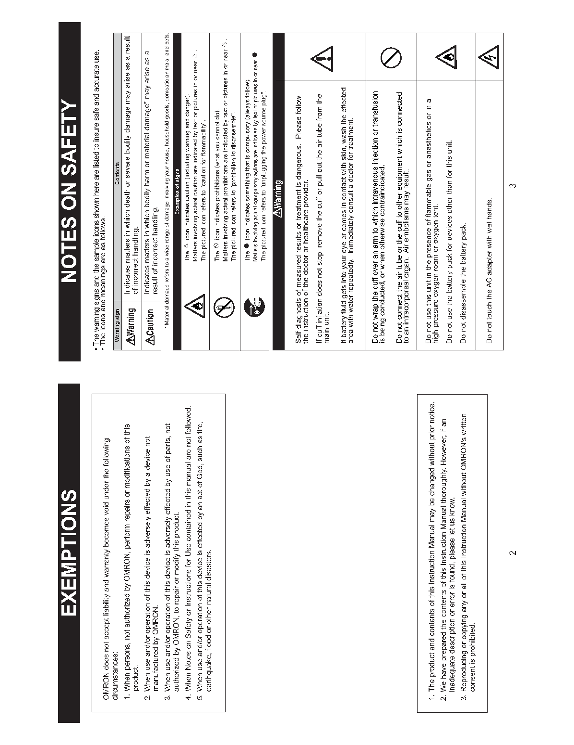



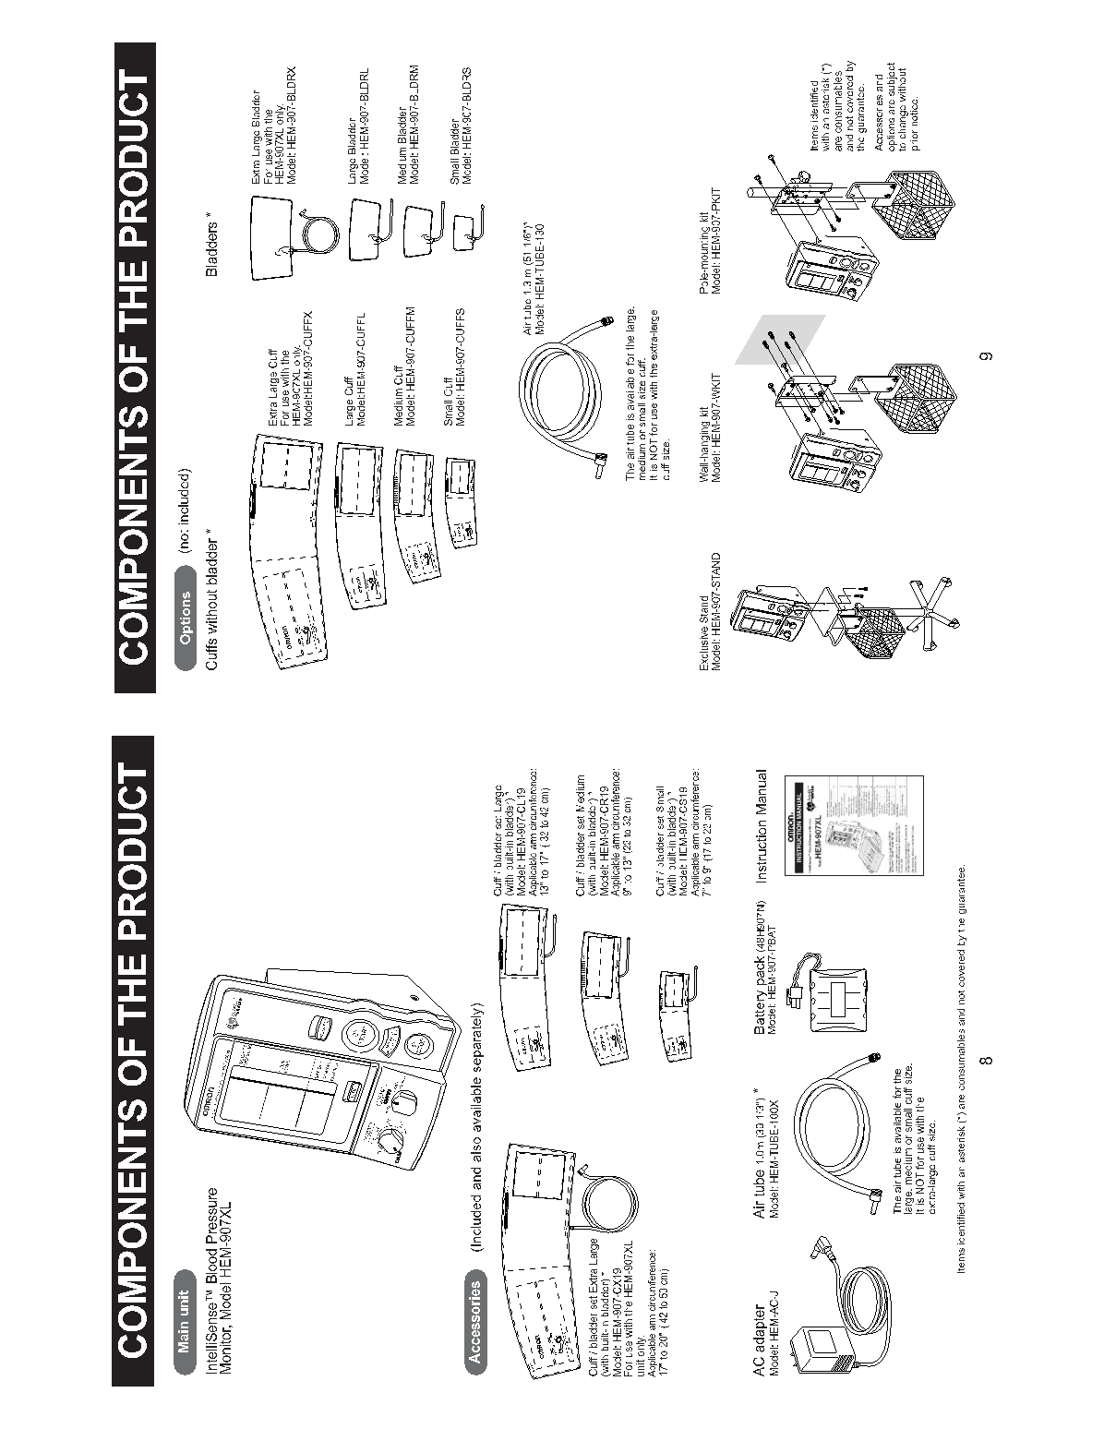

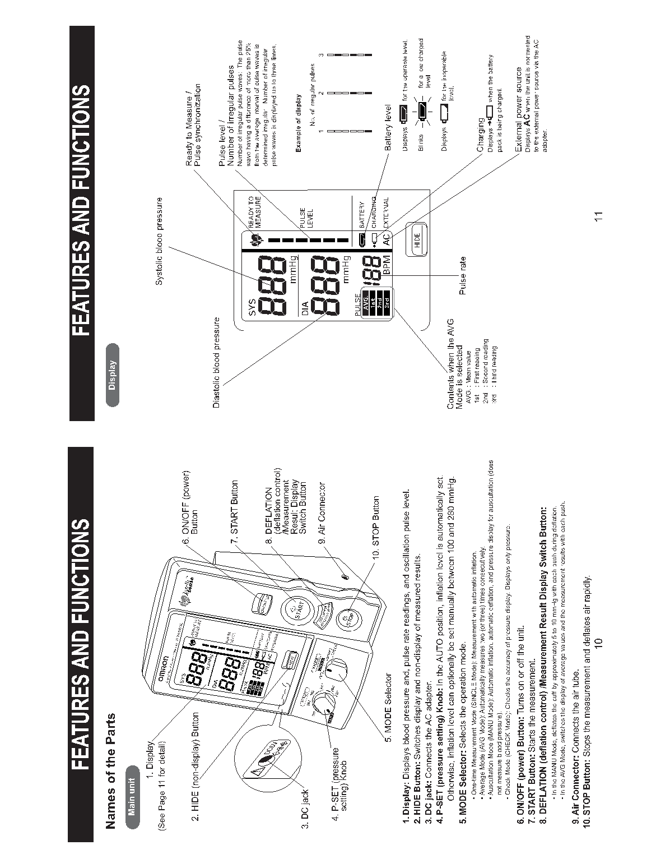

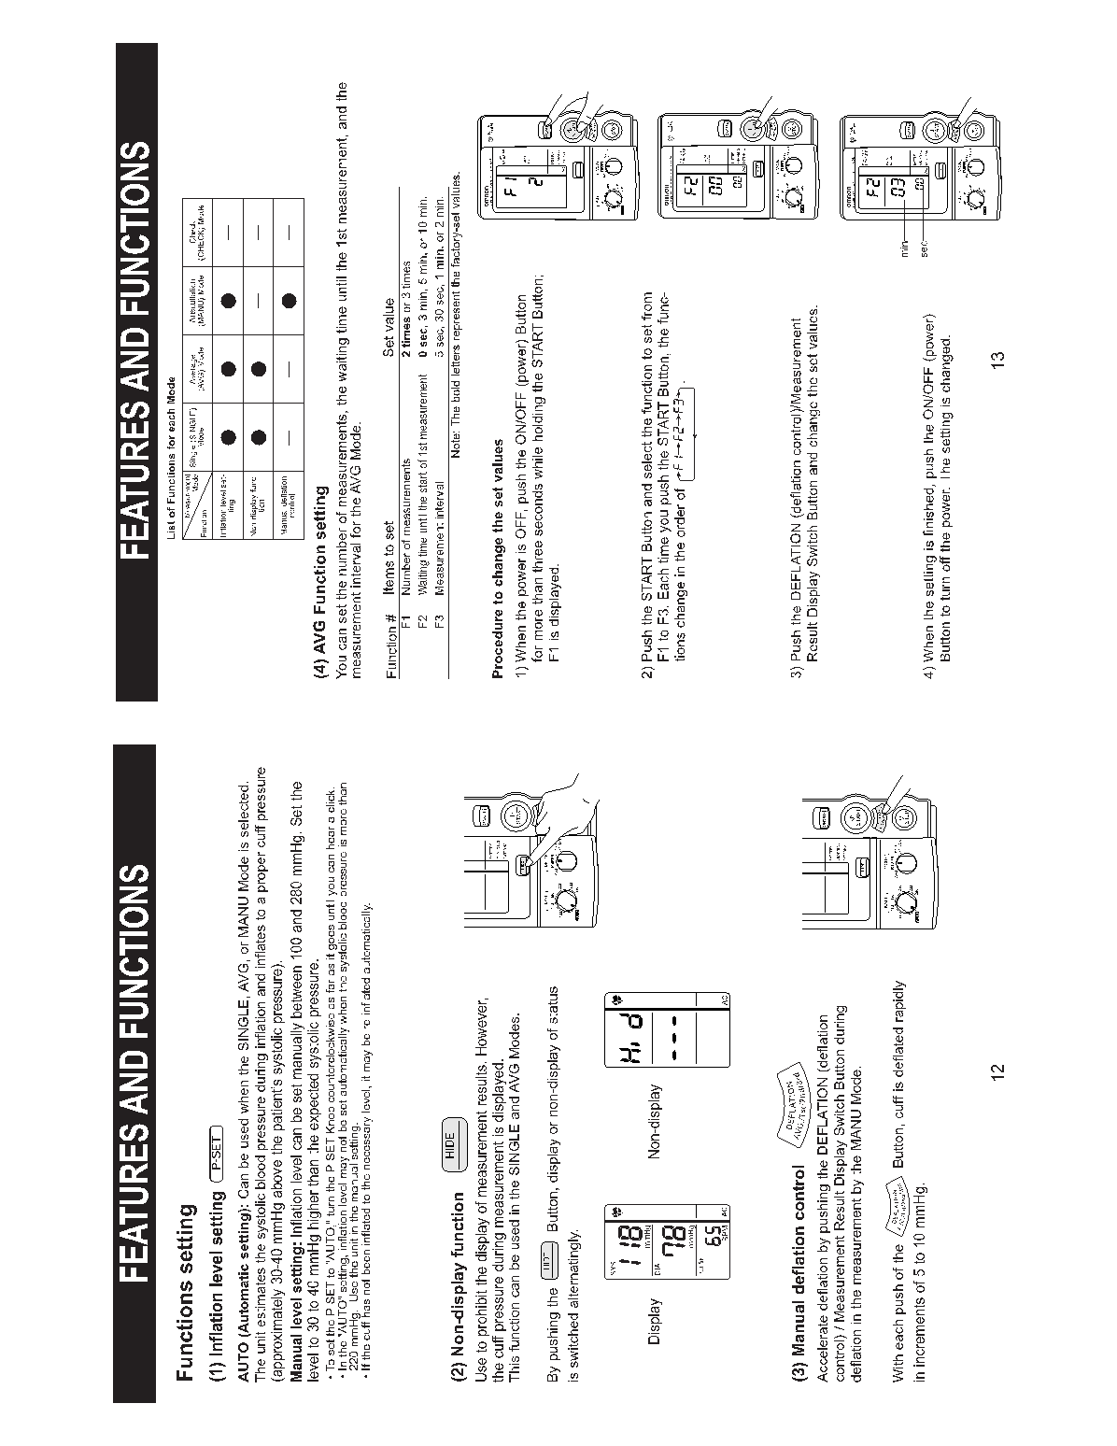

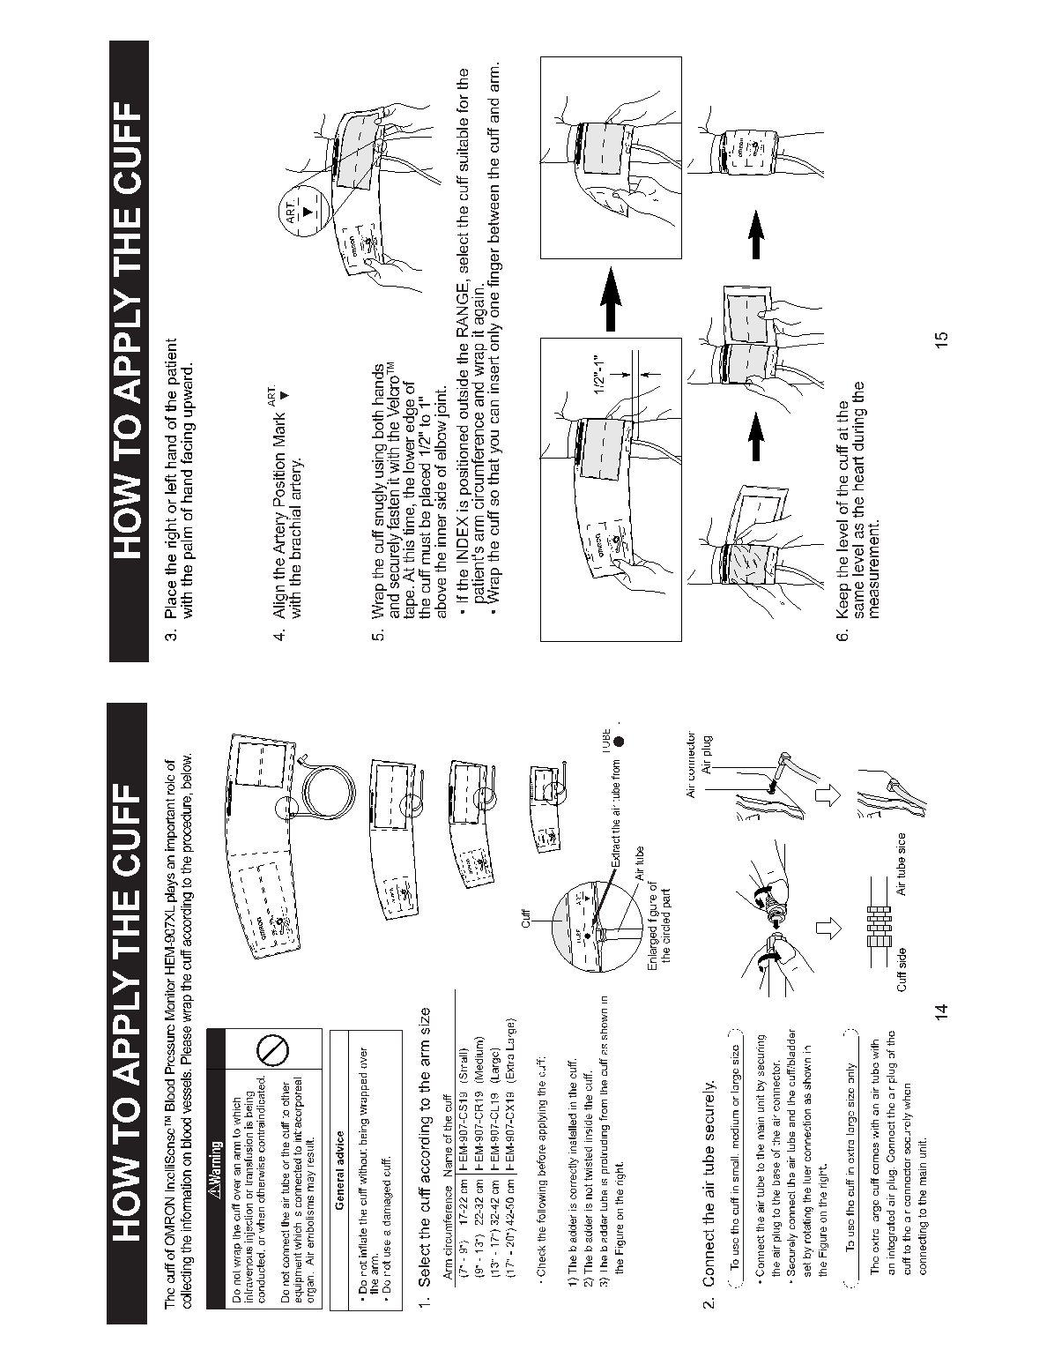

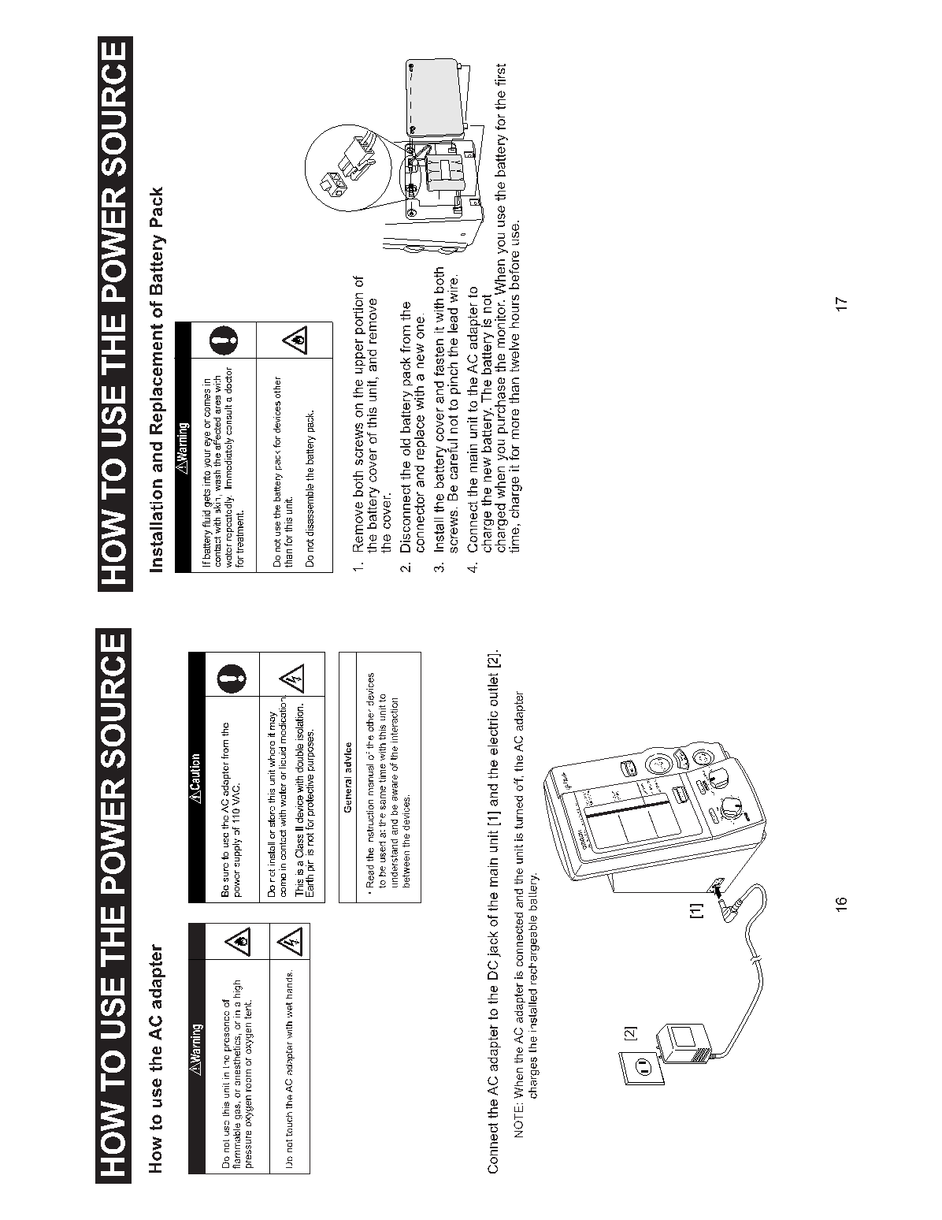

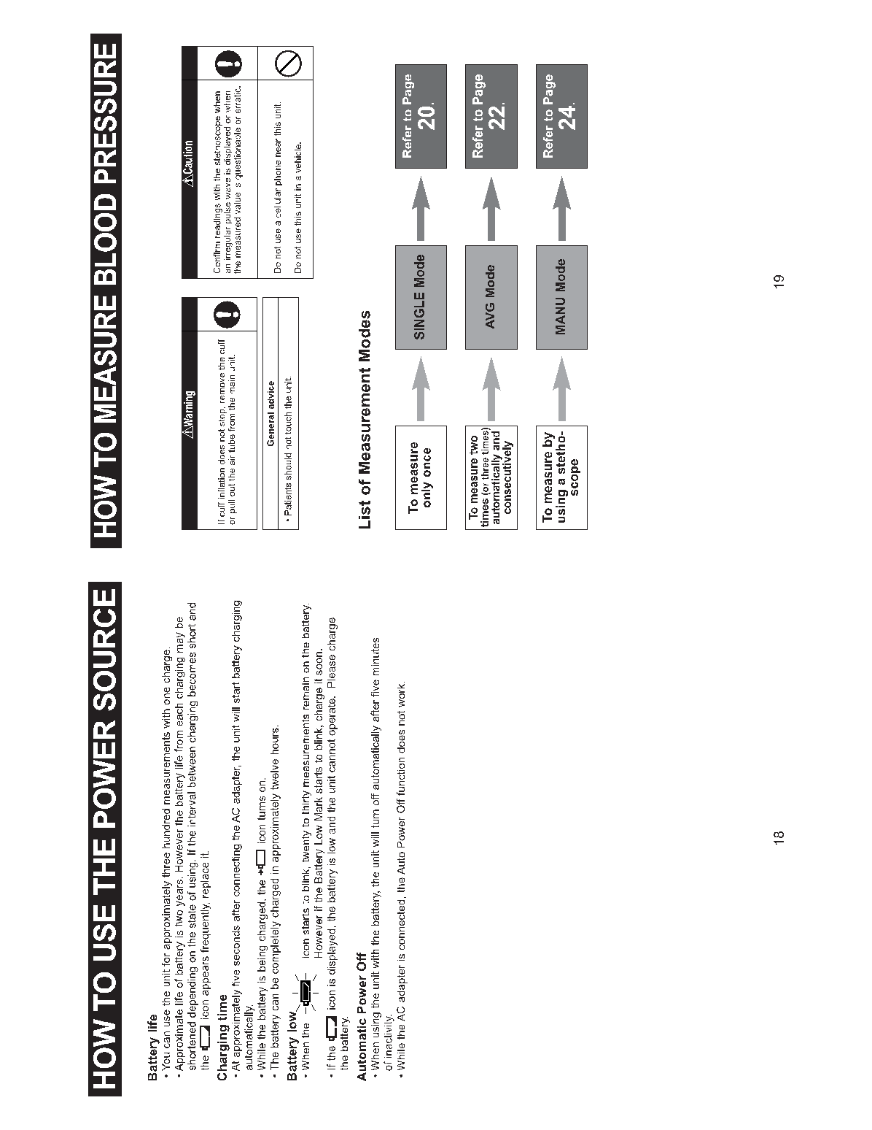

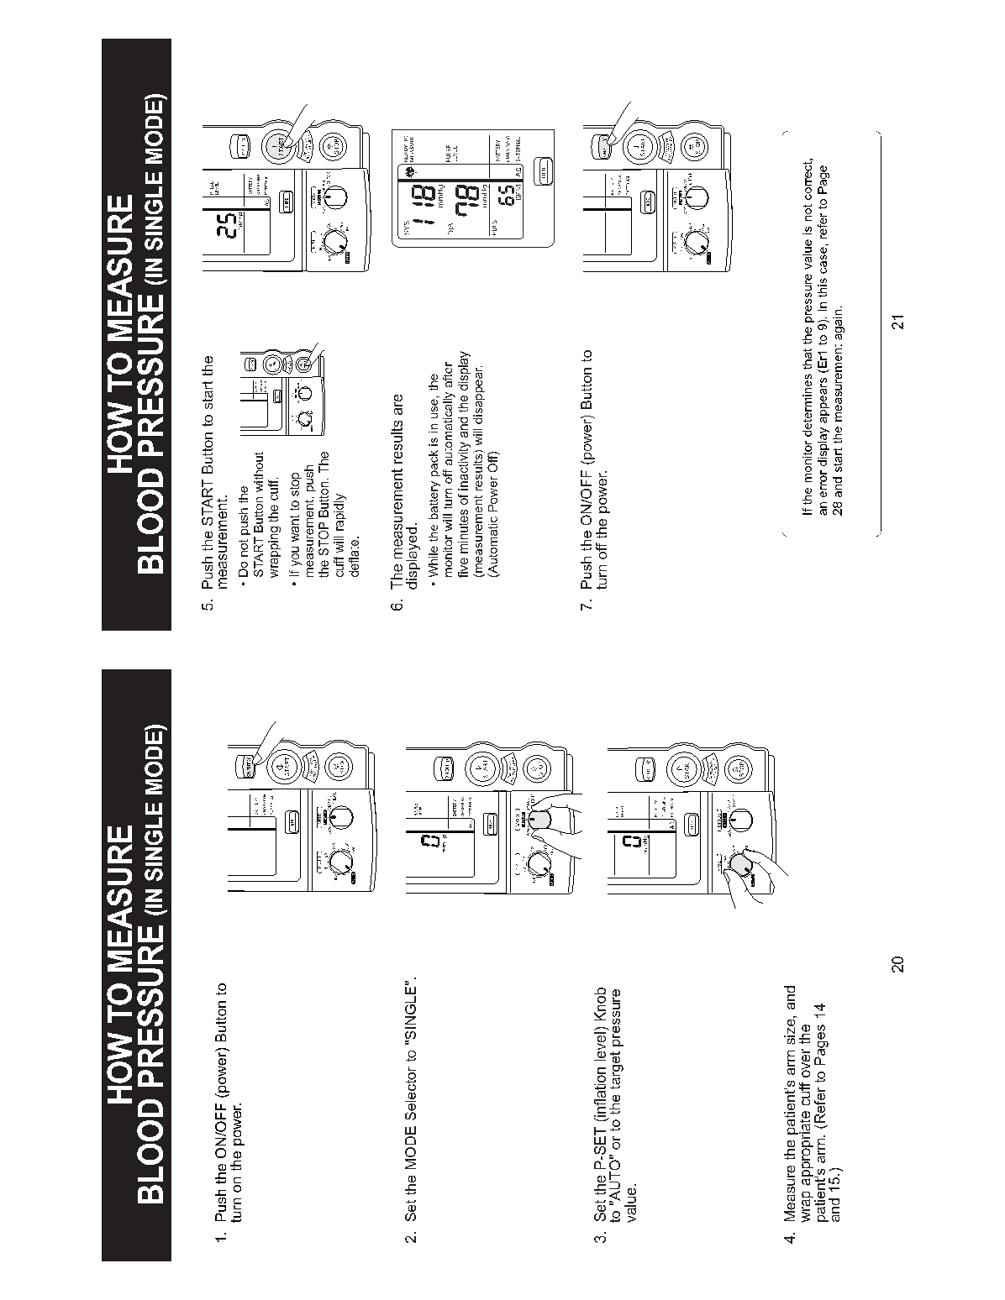
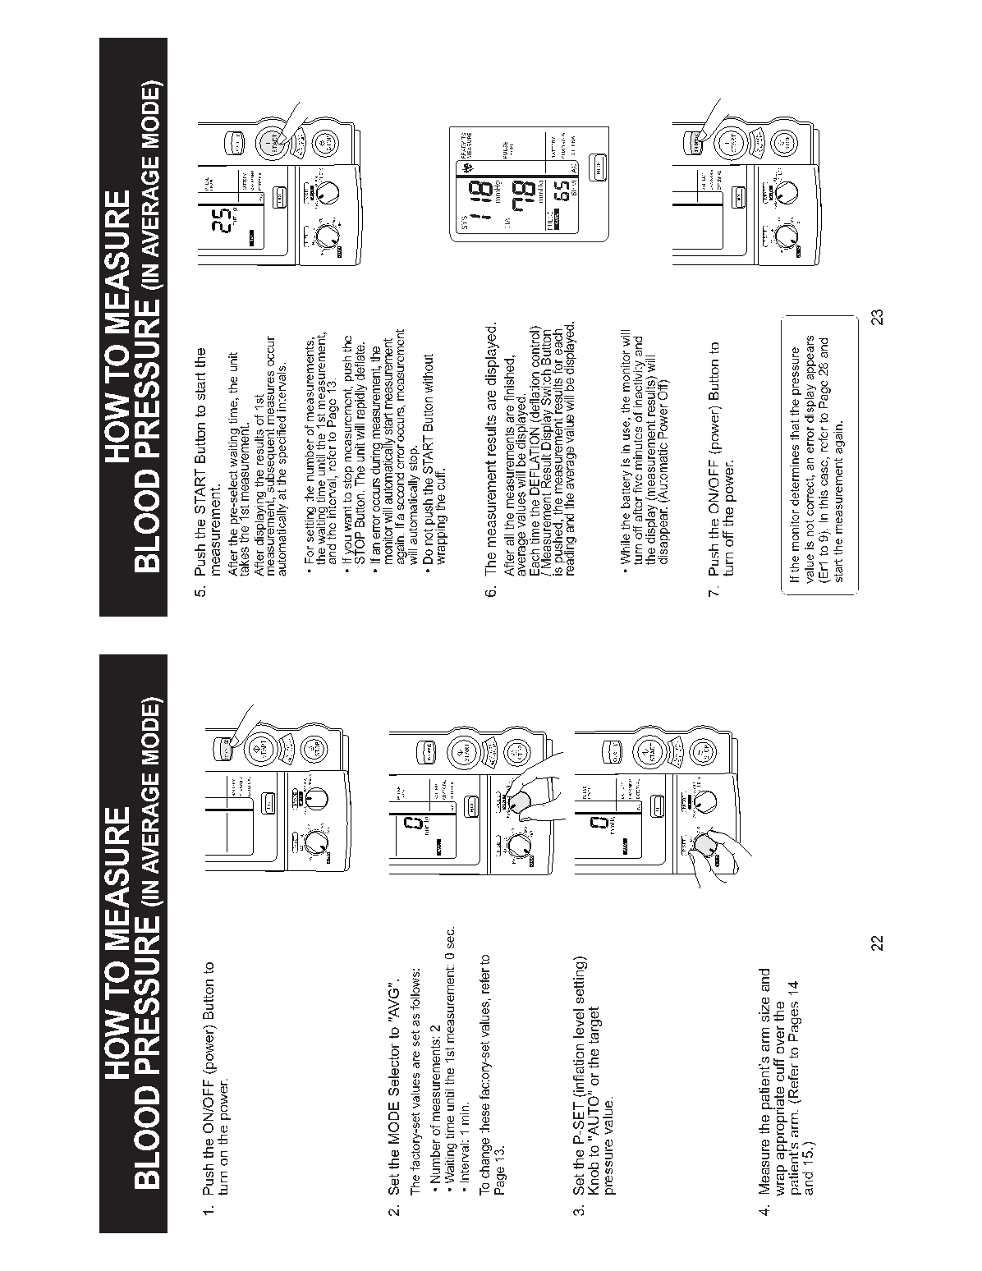
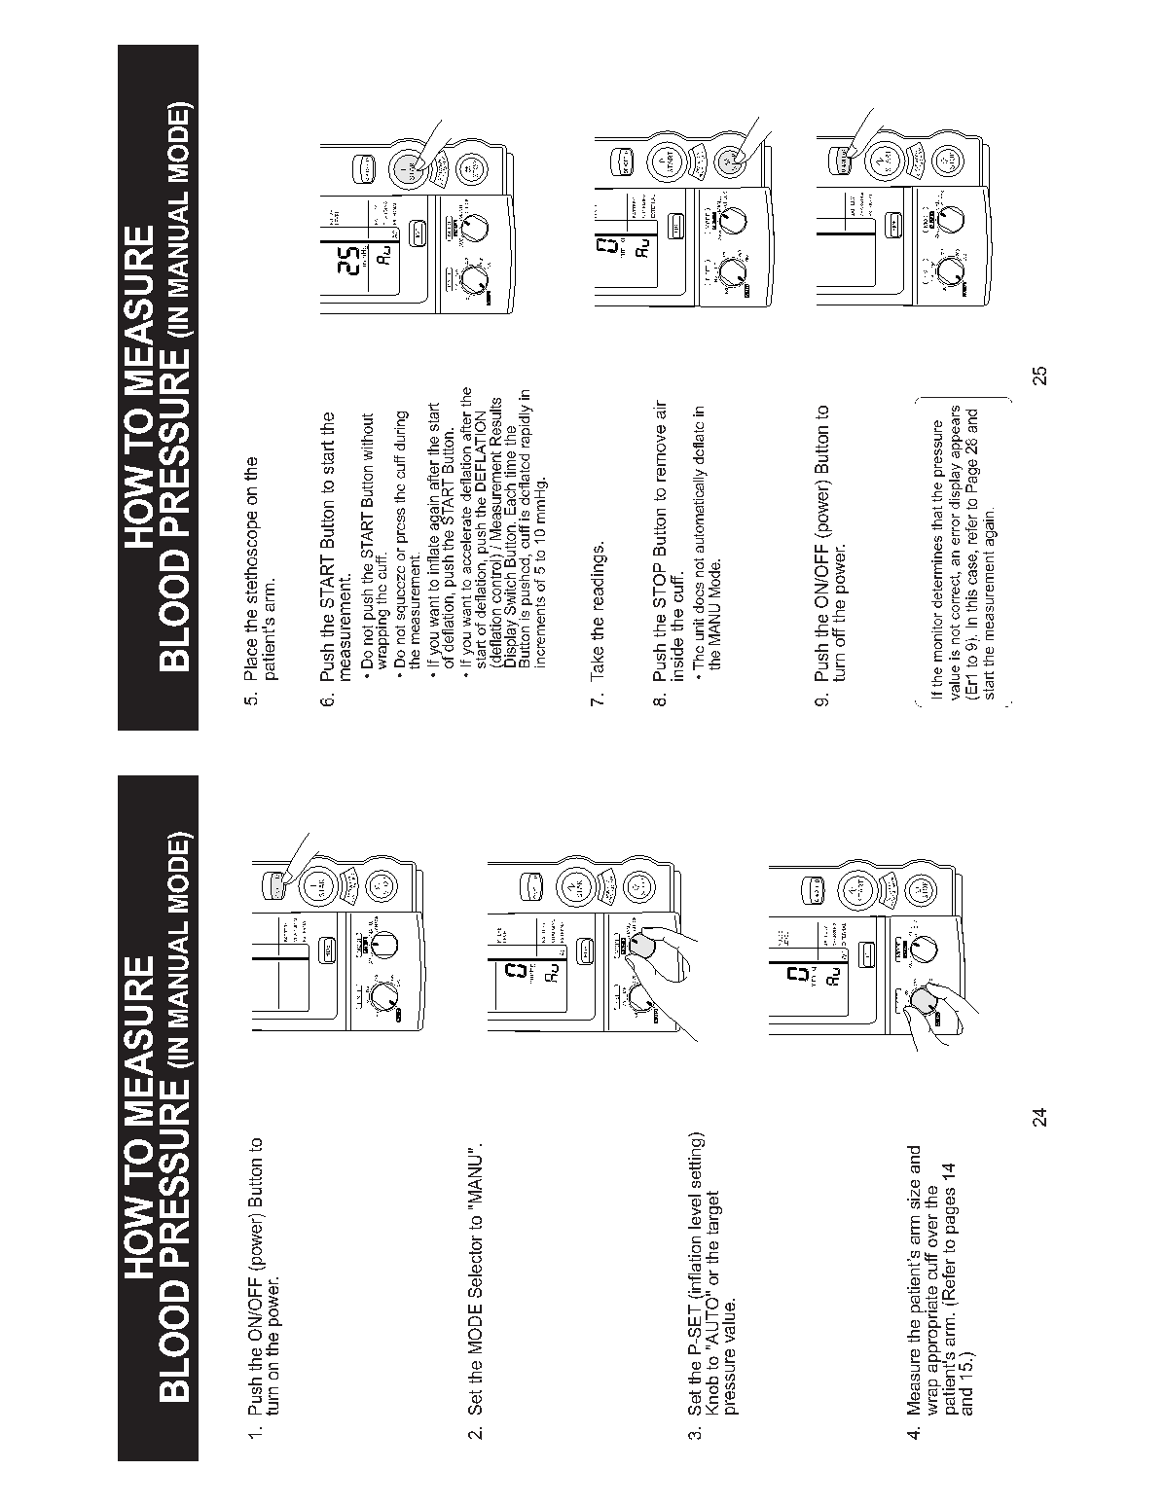

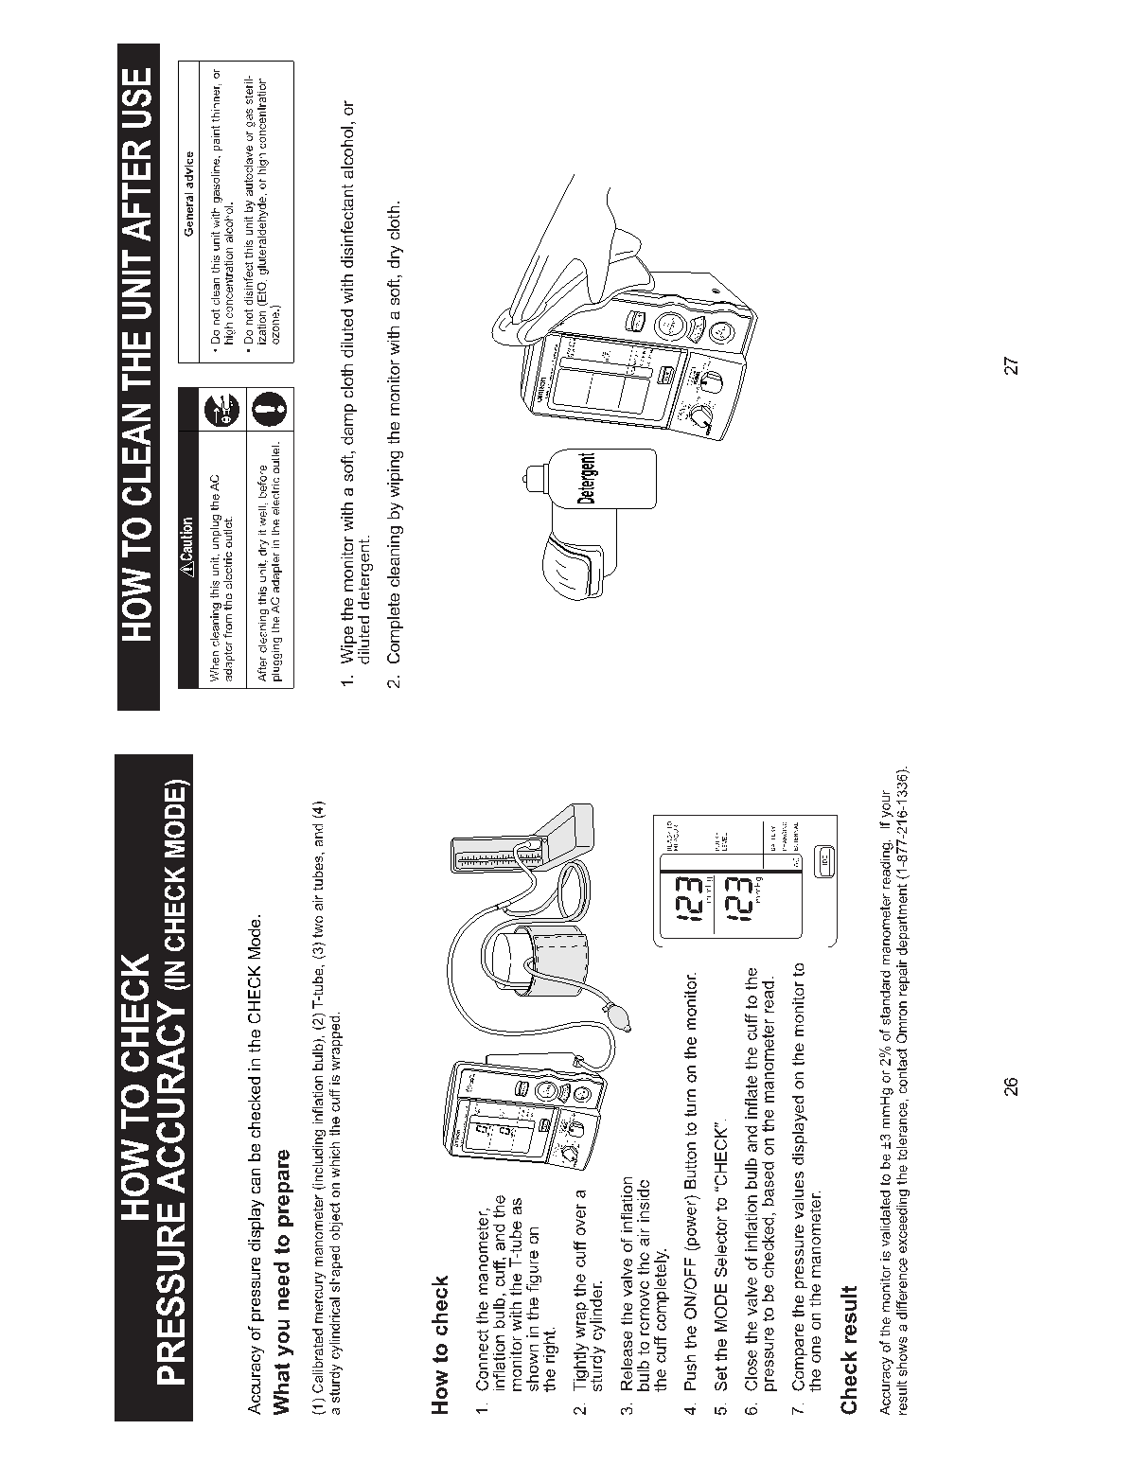
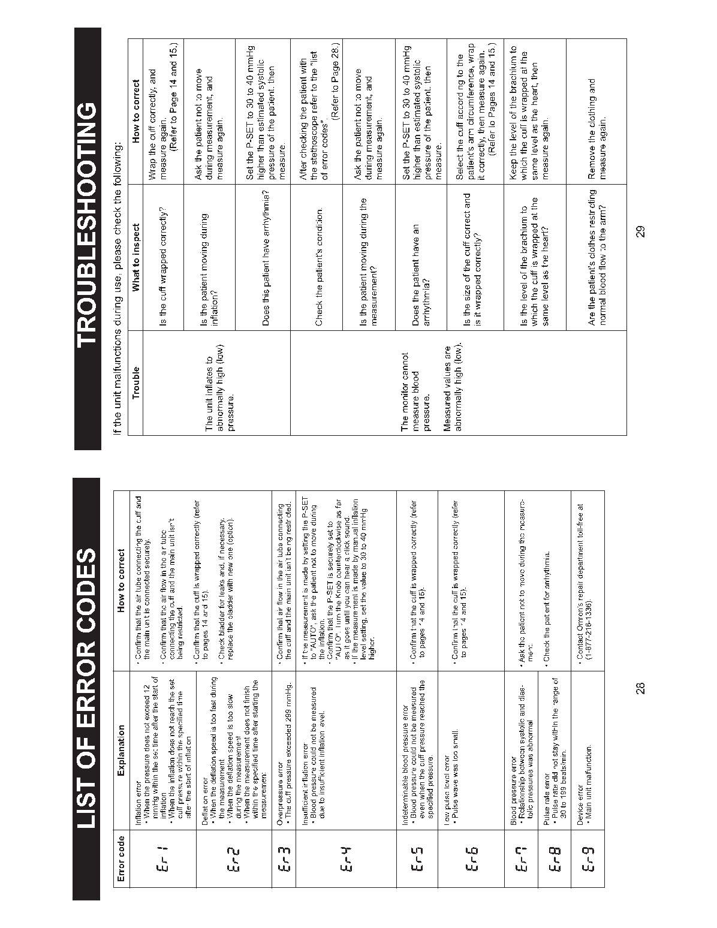




Appendix 10 Omron HEM-780 Instruction Manual

Appendix 11 Self Monitored Blood Pressure Teaching

